**Bio 104 Laboratory Manual**

**Spring 2017**

**Table of Contents**

Laboratory topics

1 Algae phylogeny

2 Mechanisms of evolution

3 Photosynthesis and Algae

4 Plant diversity

5 Plant structure and function

6 Differentiation and growth

7 Flowers, fruits and seeds

8 Population ecology

9 Field sampling

10 Campus plant walk

11 Carbon footprint

## LABORATORY STRUCTURE AND OBJECTIVES

**Laboratory Structure and Objectives:** Laboratory sections in BIO 104 are much smaller than lecture class in order to give students direct experience with a number of methods commonly used in biology and to provide opportunities for interactive learning, both with other students and with the teaching assistant (TA). Lecture and laboratory portions of the course complement each other but may not coincide exactly. You will generally be introduced to subjects in lecture first, however, so that you have adequate background for the exercises planned.

**Expectations:** Along with completing each lab exercise and assignment, we expect:

♦ **Attend all laboratory classes**  
Students will lose points from final grade for every unexcused absence.   
Missing more than three classes will result in grade of F (Fail), or I (Incomplete) with medical documentation. See URI guidelines for excusable absences. Contact your TA *ASAP* if you are going to miss a lab. Under special circumstances, you may be allowed at attend a different lab section one time during the semester.   
You will still be responsible for the work that you have missed.   
Make-up labs are not scheduled.

♦ **Be on time**. Most of the exercises require the full laboratory period (1 hour, 50 min) to complete. Important announcements, instructions, and the weekly quiz are given at the beginning of lab. Students arriving late can only take the quiz until the quiz period is over.

♦ **Be prepared for each exercise and have your lab manual with you.** The lab manual contains all the instructions for each assigned exercise. **Read each week's exercise BEFORE coming to lab**; your quiz will include questions from the day’s lab to encourage you to be prepared. Your preparedness will make the lab exercises more useful to your overall learning experience.   
**Students attending lab without their lab manual will lose 10% on their weekly quiz.**

* **Observe all lab safety rules. Follow instructions from your TA.**

No food or drink allowed in the lab EVER. No cell phones in the lab  
Wear closed-toe shoes for protection. Students not following safety rules or the TA directions will be asked to leave the lab.

**Quizzes:** There will be a quiz at the beginning of most labs. Quizzes are administered in the first 15 minutes of lab and must be taken at that time. Approximately 80% of each quiz will test on the previous lab work, while the other 20% will be questions about the lab about to start. Quizzes are designed to ensure that students 1) have learned the material presented in the previous week’s lab, and 2) are prepared to learn the new lab material.

**Assignments:** All assignments must be handed in, hard copies, during the lab period to be on time. Assignments may be handed in one week late, during the lab period, but for 50% credit. Class work must be completed before leaving the laboratory.

*Students must hand in assignments on paper (hard copies).* There are computer rooms on campus available for student use. Please plan accordingly.   
PLEASE BE WARNED: we have had many reports of student printers failing to work properly in the time period just before lab. **Printer problems are NOT an accepted reason for late assignments; if the assignment is late it will cost you 50% of your score**. We suggest you print your assignments at least few *hours* prior to your lab meeting. Again, there are computer rooms with printers on campus available for student use.

**Invasive Species Presentation & Report:**Each laboratory section will be given a list of different invasive species found throughout the world. From these, students will choose a topic for a presentation and report. The TA will provide a detailed rubric. Students with presentation anxiety are urged to talk to the TA and to ask for help from the URI Counseling Center. Students may hand in their report without giving a presentation; this will result in zero points for the presentation grade.

**Campus Plant Presentation & Report:**  Students will be assigned a tree or plant found on campus. Students will choose a plant, prepare a short report, and give ~1-2 minute presentation. The TA will provide a detailed rubric. Students must give both report and presentation.

**Academic honesty:** The University of Rhode Island and the URI Biological Sciences Department are committed to maintaining a high academic standard. We strive to insure that all students earn their grades with their own work. Cheating diminishes the work and degrees of honest students, and so cheating will not be tolerated. Cheating is defined in the URI student manual *(http://www.uri.edu/facsen/8.20-8.27.html).*Academic dishonesty includes:

* Any quiz or assignment that is plagiarized *in whole or in part.*
* Work submitted by students that are identical *or nearly identical.* (Please be aware that students are encouraged to study and review lab work in groups;  
   however, all students must hand in their own written assignments to receive credit.)
* Using material, directly or paraphrasing, from published sources without appropriate citation.
* Unauthorized use of another’s work or preparing work for another student

There are serious consequences for students found cheating.

1) TA will give student(s) a zero for that assignment or quiz.

2) Copies of the work and/or the TA’s description of cheating will be submitted to the University Board on Student Conduct.

3) Copies of the work and/or the TA’s description of cheating will be placed in a file in the Office of Student Life.

4) Subsequent infractions (cheating again in that student’s college career) will be noted by the Dean of Students who may initiate conduct action again the student.

**Additional help:  
1)**  Meet with your TA. Make an appointment and ask for additional help. If you have a problem that cannot be resolved by your TA, contact Lab Coordinator, Linda Forrester: [LindaForrester@uri.edu](mailto:LindaForrester@uri.edu)   
**2)** The Academic Enhancement Center ([www.uri.edu/aec](http://www.uri.edu/aec)) has tutors specifically for Bio 104. They can help you to learn, manage your time and work, and study well. Their days and times are listed in lab. All services are free (the coffee is free as well!), and no appointment is needed. Call for information, 874-2367, or just stop by their office.

**Students with documented special needs should notify their TA immediately** to arrange reasonable accommodations. As part of this process, please be in touch with Disability Services for Students at 330 Memorial Union (401 - 874 - 2098).

***Lab 1:* Algal Phylogeny: Phylogenetic trees**

**Objectives**:

1. Use phylogenetic trees to identify unknown species
2. Identify most recent common ancestors on a phylogenetic tree.

**Introduction**:

One of the fundamental questions that biologists ask is how biological diversity has arisen over time. To understand how organisms on Earth became diverse, biologists often examine the organism’s evolutionary history, or **phylogeny**. A graphical representation of an organism’s history is known as a **phylogenetic tree.** Phylogenetic trees are used in many fields including conservation and evolutionary biology. Today we will use a case study to explore one way in which phylogenetic trees used in science- identifying unknown organisms. If you need a basic review of phylogenetic trees see BioSkills 3 (for those with access to the e-text, Biological Sciences by Freeman- this is the back of the text).

Today’s case study is about a new “seaweed” or “macro-algal” species that has recently been observed on Rhode Island rocky shores. Macroalgae are algae that can be seen without a microscope. They are plant-like organisms that generally grow attached to hard substrate in coastal area.

**Rhode Island Algae Case Study**

Algae are critical habitat-forming, primary producers (they form the base of the food chain) in many aquatic environments. The relationship of large, macro-algae to land plants is shown below.

Green Algae

Red Algae

Animals

Fungi

Ancestral eukaryote

Three main groups of: Macro Algae

Land plants

Brown Algae

Land plants

**Figure 1: Phylogeny of eukaryotes, including algae and land plants**

You will learn more about the different types of algae in the coming weeks in lab and lecture. For now, notice there are three main groups of macro-algae: red, green, and brown (Figure 1), and their different colors reflect different pigments that they use for photosynthesis and unique evolutionary histories.

Based on Figure 1, which types of macro-algae are most closely related to land plants?

What features do they share in common with land plants?

And what are differences?

.

In today’s lab you will work in small groups to examine one of several algal samples that were recently collected off of the coast of RI. Your TA will assign you into small groups and then you will use the picture kay to identify the sample using morphology (a.k.a. what it looks like). Then you will use phylogeny to confirm whether your identification based on morphology was correct.

**Part 1: Group activity- Phylogenetic analysis**

Once you are in a group and have a specimen to identify, look at the sample provided.

Which of the three main groups of algae do you suspect this sample belongs to and why?

In order to be sure you have identified the sample correctly and to find out further information about the history of this species you will examine the phylogeny. A DNA sample was extracted from the sample and amplified using Polymerase Chain Reaction (PCR), similar to what you did in BIO 103 last semester. Then the PCR product was sequenced. A portion of the sequence for each algal sample is provided by your TA. The steps below will walk you through the process of using a database to identify the sample by creating a phylogenetic tree from its sequence. We will use the database called “BOLD.” This stands for the Barcode of Life Data systems. BOLD is a publically accessible workbench that contains DNA barcode records.

Follow the steps below to determine what species your sequence matches and to generate a phylogenetic tree of related species.

1. Go to <http://boldsystems.org/>
2. Select the “Identification” tab at the top of the page.
3. Select the “Animal Identification [COI]” tab. Select the “Species Level Barcode” option. Then copy the sequence located on your classes Sakai site into the appropriate box and hit submit.
   1. According to the results page, what species did your sequence match?
4. Now click “Tree Based Identification” and then “View Tree” to generate a phylogenetic tree that includes your sample. You will notice that the sample will fall in a large cluster.
   1. What species is in this cluster?
   2. What is the nearest neighbor to this cluster
   3. Based on the phylogeny, are you able to hypothesize where this species is from?   
      (Is it native to New England?) Explain your answer.
5. You probably need more information to answer question c above. Go back to the search results page. Now visit the species page.
   1. Take a look at the images provided on the species page. Does your sample resemble these images? List the similarities and some differences.
   2. Take a look at the map at the bottom of the page.   
      Where are some other locations this species is found?
   3. Based on the map, phylogenetic tree, and species name, where do you think this species originated?
   4. Did your identification based on morphology match the one made using the sequencing data and phylogenetic tree?
   5. Why do you think sequencing data and phylogenetic trees can be helpful in identifying species? What do you think you can learn about a species history from a phylogenetic tree?

**Part 2: Analyzing an Active Invasion**

One of the species that was examined by some of the groups in class was *Heterosiphonia japonica.* As you might guess, this originated in Japanso it is surprising that is has made it all the way over to Rhode Island. How did this happen?   
 Read the abstract of the article Newton et al. 2013 (available on the class Sakai site) to learn more about how this species traveled from Japan to the coasts of RI.   
Answer the questions below after reading the abstract.

1. Does the range of *H. japonica* in the western North Atlantic seem to be increasing?
2. How recently did this increase in range occur?
3. What is so impressive about the new range of *H. japonica* in the western North Atlantic?
4. What was the highest abundance of *H. japonica* observed?
5. What is one effect of *H. japonica* on community structure that has already been observed?

Our last step in this lab is to interpret data (from the Newman et al. study) in order to better understand the impacts of the *H. japonica* invasion. But first, let’s recap some important points about data analysis that you may have forgotten from BIO 103:

**Overview of Scientific Data**

Throughout your scientific career you will be expected to produce graphs and tables to present your data. It is useful to have a guidebook to instruct you how on data presentation. The University of Rhode Island Biological Sciences Department recommends “**A Short Guide to Writing about Biology**” by Jan A. Pechenik. There are many editions, all will be helpful. Currently, the most recent edition is available for sale in the URI bookstore. The 7th edition is very useful, and it can be purchased from many sources (ISBN-13: 978-0-205-66727-7) and 20 copies are available for free, on loan, in the URI Kingston Library.

Your Bio 104 TA will expect you to produce your tables and graphs in a computer program. This is not to torture you. You will need to produce graphs and tables in some computer program throughout your scientific career. One of the goals of the introductory biology labs is to help you to learn the skills you need to become successful in your field, and graphing is a necessary, basic skill.

Following are some helpful hints to aid you in producing tables and graphs in a scientific manner. This is by no means an exhaustive list; it simply covers some basic topics.

**Data**

Data can usually be separated into two types: **discrete** and **continuous** data. Discrete data are data that are in categories, the data are distinct or separate; for example: types of junk food (Doritos, marshmallows) or plants grown in two conditions (light, dark), or something that can be counted (number of petals on a flower). Continuous data are data that can be described by an increasing scale with an infinite number of possibilities between the intervals; continuous data includes time, weight, height, temperature, etc.

**Variables**

When you conduct an experiment, you decide (or your TA decides for you) what you will alter, and what you will measure. When you burned food in Bio 103 for the junk food calorimetry lab, you independently chose what food you would burn. This was your **independent variable**. During that experiment, you measured the amount of heat given off by that food. The temperature you measured was higher or lower, depending on what food you chose. Temperature was the **dependent variable**.

By convention, we put **the independent variable on the x-axis (the horizontal axis)**.   
We put the **dependent variable on the y-axis (the vertical axis)**. Unless you have data for the third dimension (the z-axis), you should create a graph two dimensions only.

**Tables**

As a general rule, for data tables in Bio 103 and Bio104, follow the rubric assigned by your TA. If you do not have clear instructions, present your raw data and your summary data in a way that clearly shows the trends that you found. Present ALL your data, even data that you think is “bad.” If you have a reason to not include a data point (e.g. the vial fell to the floor and the seedling was cut into pieces) include data you have until that point, and then describe what happened at that point.

Label tables so it is clear what the data represents WITHOUT reading an entire lab report. Table labels should always be at the top of the table. Be sure to format tables for submission to fit onto one page when printed.

**Graphing**

In a scientific paper, you generally present data in a data table OR on a graph. You do not present the same data in both, unless there is a very good reason for it. However, in Bio103 and Bio 104, your TA is trying to see that you know HOW to present data, so you will usually present the data in both forms.

There are many types of graphs to create. Always choose a graph that best fits your data. **For discrete data**, it is often best to use column or a pie graph. **Column graphs** (also called vertical bar graphs) allow for presentation of discrete categories. See the example column graph below.

Y-axis

Use descriptive axes labels **with units.**

Put caption BELOW graph.  
Give complete info in the figure caption. Figure should be understood independently of lab report. Caption should tell reader what was plotted and the number of measurements making up each mean value.

X axis

**For continuous data**, use an XY scatterplot; this is designed to present data that is variable on the X and Y scales. Plots can be presented with or without lines. Lines are included connecting the points to show how points relate to each other, or as a trend lines, showing a summary of the data.

Note: descriptive axes labels with units.

**

Figure legend identifies data on graph

GRAPHS have a caption, placed **below** the graph.   
(TABLES have a title **above** the table.)

Error bars

*Why do we need error bars?* Use error bars to show the variability in the numbers that were used to calculate the mean. If the numbers used to calculate the mean were very similar, the error bars are small. If the numbers used to calculate the average were very different (or variable) then the error bars are much bigger.

Different values that can be used to show variability. Some people show the variation with an error bar representing the **Range** (min and max values). For the range, your error bar will extend down from the mean to the lowest value (minimum) and up from the mean to the highest value (maximum). Some people show variation using **Standard Deviation (SD)**. You can use the Excel formula (=STDEV) to calculate SD. (Do not simply click on the “standard deviation” option within the Excel graphing program as this gives one standard deviation for all the values on your graph.) You should calculate the standard deviation (=STDEV) within the excel spreadsheet and then use those values for your graph. SD value on a graph is shown as a bar going up from the mean one standard deviation, and down from the mean by 1 SD.

Remember

**X-axis** – horizontal axis – shows independent variable

**Y-axis** – vertical axis – shows dependent variable

**Figure caption**:

-Describes graph without reading paper (short paragraph)

-Always located BELOW graph

**Ready to graph?**

To test your understanding of how graphs can be used to interpret scientific results, let’s use some data from the Newton et al. 2013 article you referred to earlier in this lab.

Using the data below in Table 1 make a scatter plot in excel (follow format in Figure 3). Note the format of Table 1. When making a scatter plot, formatting your table like this will make it easier for you to create graphs quickly in programs like Excel.

1. If species richness is your independent variable and mean percent cover of *H. japonica* is your dependent variable then:
   1. What variable will be on the x-axis?_________________________________
   2. What variable will be on the y-axis? _________________________________
2. Now create a scatter plot using the data in Table 1. Make sure to include necessary components outlined in Figure 3.
3. What conclusions can you draw from your scatter plot? (Hint: Think about independent and dependent variables).

Table 1. Species richness and mean percent cover of H. japonica from each plot.

|  |  |
| --- | --- |
| Species Richness | Mean percent cover of  *H. japonica* |
| 6 | 40 |
| 7 | 70 |
| 8 | 40 |
| 10 | 0 |
| 12 | 2 |
| 12 | 15 |
| 11 | 30 |
| 11 | 31 |
| 14 | 0 |
| 14 | 15 |
| 17 | 2 |
| 19 | 0 |
| 20 | 5 |
| 20 | 8 |
| 20 | 35 |
| 21 | 0 |
| 21 | 2 |
| 24 | 0 |
| 25 | 20 |



Now let’s try a column graph.

1. Finish calculating the mean and standard deviation of % cover of *H. japonica* for each location.
2. Create a column graph showing mean and standard deviation of each site. Make sure to include a figure caption, axis labels and error bars. Look back at Figure 1 if you need an example.
3. Show your table and graph to your TA. Demonstrate the formulas you used to calculate the mean and standard deviation.

Table 2. Percent cover of *H. japonica* from locations in RI. Three plots were examined at each location.

|  |  |  |  |  |  |
| --- | --- | --- | --- | --- | --- |
| Location | % cover of *H. japonica* | | | Mean % cover of  *H. japonica* | Standard Deviation |
| Plot 1 | Plot 2 | Plot 3 |
| Kings Beach, Newport | 0.7 | 3.2 | 2.3 | 2.1 | 1.3 |
| Fort Adams, Newport | 10.1 | 20.2 | 10.3 |  |  |
| Fort Wetherill, Jamestown | 30.4 | 8.3 | 18 |  |  |
| State Pier #5, Narragansett | 0.2 | 1.2 | 0.6 |  |  |

After completing your graph answer the following questions.   
 Make direct references to your table and graph.

1. Of the sites:

A) Which site had the highest percent cover of *H. japonica*?

B) How do you know? (What data specifically supports your answer to part 1A?)

C) If you were to start a monitoring program, aimed at limiting impacts of this invasive species on local marine biological diversity, and only two stations could established   
(due to limited funding and time), **then which two sites would you choose to establish**   
as on-going monitoring study sites?  
  
__________________________ and __________________________

D) Why did you choose these two sites?

**SUPPLEMENTARY MATERIAL**

Help! I still don’t understand Phylogenies!

Biologists think about the relationships among populations and species in a way that is similar to how we think about our family’s history. In fact, there is a lot of similarities between a family tree and a phylogenetic tree. Let’s use your family tree as an example.

[1] In the space provided below draw your family tree. Include yourself, siblings, parents, aunts or uncles, cousins and grandparents. You are related to both your sibling and your cousin (if you are an only child let’s pretend you have a sibling). To which of these relatives are you more closely related? Why?

[2] Who is your most recent common ancestor with your sibling? _____________________  
  
Who is your most recent common ancestor with your cousin? _____________________

[3] Who lived more recently (came later)?  
Your most recent common ancestor with your sister, or your most recent common ancestors with your cousin?

[4] After answering questions 2 and 3 do you still agree with your answer to question 1?   
If not, who do you now think you are more closely related to, your sibling or cousin?

Hopefully you now agree that you are more closely related to your sibling than to your cousin. This is because your most recent common ancestor with your sibling (your parent) lived more recently than your most recent common ancestor with your cousin (your grandparent). Similar reasoning can be applied in thinking about the evolutionary relationships among populations and species.

## Lab 2: MECHANISMS OF EVOLUTION

**Introduction**

For hundreds of years, biologists have known that traits of living organisms change over time. The scientific debate is not over ***whether*** change occurs but ***how*** this change happens. What are the mechanisms of evolution? What processes cause morphological (or other types of change) over time? Are the changes produced similar among different processes? How long does it take for changes to become noticeable?

These are issues first raised clearly by Charles Darwin in the mid 1800s, and today evolution has become the unifying framework for all other fields of biology.

Evolution is the accumulated inherited changes in individual traits in a population over time. These accumulated changes can be driven by several forces including natural selection, mutation, migration and genetic drift.

The purpose of today’s experiments is to examine ***how*** populations change over time when exposed to two different environmental situations: natural selection and genetic drift.

1. Experiment 1: Some individuals will survive and have higher reproductive success because of some trait(s) they have (color, size, shape, etc). If these beneficial traits have a genetic basis, they will be inherited by the next generation. This is called **natural** **selection**.
2. Experiment 2: Some individuals survive and reproduce better than others due to *chance* alone, and not because of any *particular* trait they might have. These surviving parents will pass on their traits to their offspring. This is called **genetic drift**. In a large population, genetic drift may have very little effect on the populations’ traits. However, in a small population, genetic drift can quickly decrease the amount of genetic variation in a population.
3. Experiment 3: Only a few individual s will survive a devastating event. This population will start the following generations. This experiment will demonstrate the **founder effect,** one particularly dramatic example of **genetic drift.**

This lab will simulate these two major mechanisms of evolutionary change by comparing how a population responds to the two situations described above. **At the end of the lab, you will analyze your results as well as the findings of the entire class.**

**Procedure description** 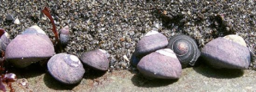

You will measure changes that occur within a population of snails. These snails inhabit the rocky ocean shoreline. The snails cling to the rocks, scraping algae (their food) from the rocks.

These snails are exposed to **two main sources of mortality**:

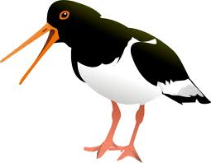

A. **Oystercatchers** are large seabirds that hunt for snails visually. The color of the snails affects their survival when oystercatchers are present because some colors are more easily seen (and eaten) than others. Your TA may show you short video clips of oystercatchers foraging along a rocky shoreline.

B. **Drifting logs** are slammed into the rocks by waves and crush snails randomly. Snail color has no effect on whether it is crushed by a log or not.

**The scenario**: Each group of two students will be given their own “tide pool” containing an assortment of “empty snail shells” and a number of “live snails.” We will run two experiments on the snails in the tide pool, to look at changes in the population over generations.

**Experiment 1- Oystercatcher**: One person in each group will act as the oystercatcher (seabird) and will feed on the **live** snails, eating LIVE snails, counting the number consumed, allowing snail reproduction to occur, and then feeding on snails again, for three snail generations. We will examine what changes occur to the color of the snail population over time.

**Experiment 2 – Drifting log**: One person in each group will act as the drifting log, and will blindly crush the snail shells, of any color, living or dead. After each crushing event, the live snails will be allowed to reproduce. Then, the crushing of snails will occur again, for three snail generations. We will examine what changes occur to the live snail population over this time.

**The reality in the lab**: While some people might enjoy eating snails or crushing and killing all these snails, we try to run a more humane lab here at URI. Your “tide pool” will be represented by a white plastic bowl. Your “empty snail shells” will be represented by white and red colored beads. Your “live snails” will be represented by white and red colored beads with pale yellow threads (snail bodies) tied through the beads. Both live snails and empty snail shells look very similar on first glance.   
**Like real birds, you will have to examine the shells (beads) to see if they contain a live snail.** With the white live snails (represented by yellow thread in white beads), the white or yellow thread against the white bead may be more difficult to see than yellow thread against the red beads. This difference may make the white live snails more difficult for the oystercatcher (you) to find. This may change the snail population (based on shell color) over time.

**Real world**  **Bio 104 lab simulation** .

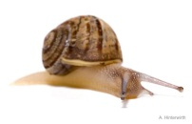

LIVE snail = bead with string

Empty shell = bead, no string

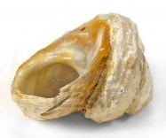

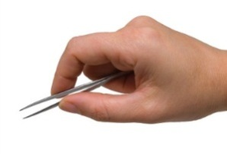

Oystercatcher (bird that eats snails) = forceps



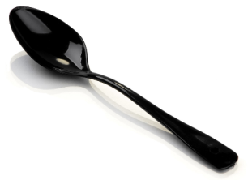

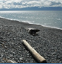

Snail crushing drifting log = spoon

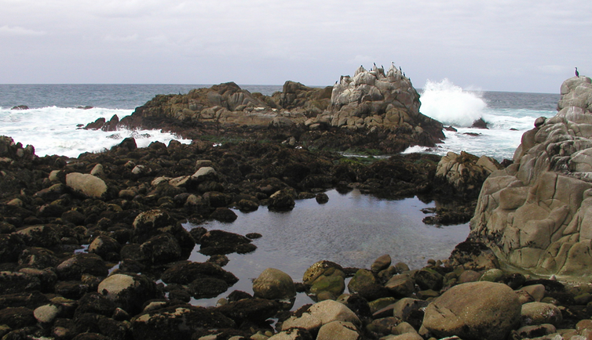

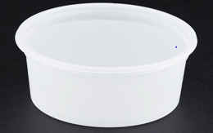

Tide pool = white plastic bowl

**Procedure —**

Start all 3 experiments with tide pool (white plastic bowl) containing:  
 25 live red snails (red beads, with strings)  
 25 live white snails (white beads, with strings)   
 25 red shells (red beads, no string)   
 25 white shells (white beads, no string)

This is your starting generation (G0); record the number of live individuals of each color in the table.

**Exp 1: Oystercatcher experiment:** As an oystercatcher bird, you will hunt for live snails visually.   
Eat snails until you have removed half of the **live** snails present. Do not remove empty shells.

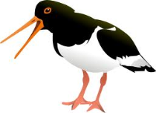

1. Mortality Episode 1: Hunt and remove 25 **live** snails in your tide pool.   
Remove 25 live snails (beads WITH strings).   
Work as fast as possible.

Do not remove empty shells from your tide pool; you cannot eat them so they remain constant.

2. Reproduction Episode 1: The 25 snails removed from your habitat are eaten, so they are dead.   
They cannot reproduce. The 25 individuals remaining in the tide pool survived the first episode of mortality, and they now can reproduce.   
For every surviving live snail, add 1 new snail of the same color.  
The new population has 50 live snails: 25 survivors and their 25 offspring   
 – this is generation 1 (G1). Record the number of individuals of each color present.

3. Repeat 2X (for a total of three mortality episodes and three bouts of reproduction).   
After each reproduction event, you will have 50 living snails in your tide pool.

**Exp 2: Drifting log experiment A:** As a drift log, you will kill half the snails in the tide pool.

4. Mortality Episode 1: With drift log (spoon), **remove 25 live snails**.  
If you remove empty shells, leave them out.

5. Reproduction Episode 1: The empty shells and live snails crushed and removed from your tide pool cannot reproduce. The live individuals remaining in the tide pool survived the first episode of mortality, and they now can reproduce.   
For every surviving live snail, add 1 new snail of the same color. Do not replace empty shells.  
This will be your first generation (G1), Record the number of individuals of each color present.

6. Repeat 2X (for a total of three mortality episodes and three bouts of reproduction).   
After each reproduction event, you will have 50 living snails in your tide pool.

**Exp 3: Drifting log experiment B — Bottleneck effect experiment**

7. Mortality Episode 1: With a drift log (spoon), **remove all but 2 live snails**.

8. Reproduction Episode 1: For every surviving live snail, add 24 new snails of the same color.   
This will be your first generation (G1). Record the number of individuals of each color present.

9. After this one bottleneck generation, repeat the mortality and reproduction episodes two more times but remove only 25 snails (as you did in experiment 2.)  
After each reproduction event, you will have 50 living snails in your tide pool.

**Data Tables**



**DATA ANALYSIS**

1. **Fill in the tables with your data. Record and share your data with the class**. Use the numbers from the “Start” row from the data table above to represent the population size for each generation in your experiment for your group. Write these numbers on the white board to share with the class.

2. After you have data from the class, you will be able to **make a data table to hand in next week.** This data table will have your data in a format that is most convenient for graphing.   
Below is an example table for oystercatcher data. You will want to produce something similar to hand in, as well as a second table showing your “Drifting log” data.   
Calculate standard deviations for the class data set.

3. **Graph your data as a line graph** (use EXCEL or a similar spreadsheet program) with generation number on the X-axis and 'number of snails' on the Y-axis. You will have two lines on your graph, one for the more obvious, red snails and one for the more cryptic, white-shelled snails. Summarize the consequences of mortality acting on your snail population over 3 generations.

4. **List all class data**. List the similarities and differences among your results. Do the data collected by different oystercatcher and drifting log groups all look basically the same? Why or why not?   
  
Are the differences among groups large enough to be significant? (This requires some statistics; a Student's t-test would work.)

5. **Compare** the results of oystercatcher mortality with those of drifting logs on color of snail populations. Do these two mechanisms of mortality produce similar results?

**6**. **Present both your small group data and the average class data**. Prepare a graph summarizing the changes in the two snail populations under oystercatcher effects and under drifting log effects (due next lab). You should present average changes in the populations, showing St Dev bars around the means. Based on overlapping bars, predict whether the class data suggests differences in the populations over time. Explain.

Class Data

Enter each group’s “ **START count** “ number of snails for generations 1-3.

|  |  |  |  |  |  |  |  |  |  |
| --- | --- | --- | --- | --- | --- | --- | --- | --- | --- |
| Experiment 1 Prediction: | | |  |  |  |  |  |  |  |
| Oystercatcher Exp. | | Generation 0 | | Generation 1 | | Generation 2 | | Generation 3 | |
|  | Group Name | Red | White | Red | White | Red | White | Red | White |
| Group 1 |  | 25 | 25 |  |  |  |  |  |  |
| Group 2 |  | 25 | 25 |  |  |  |  |  |  |
| Group 3 |  | 25 | 25 |  |  |  |  |  |  |
| Group 4 |  | 25 | 25 |  |  |  |  |  |  |
| Group 5 |  | 25 | 25 |  |  |  |  |  |  |
| Group 6 |  | 25 | 25 |  |  |  |  |  |  |
| Group 7 |  | 25 | 25 |  |  |  |  |  |  |
| Group 8 |  | 25 | 25 |  |  |  |  |  |  |
| Group 9 |  | 25 | 25 |  |  |  |  |  |  |
| Group 10 |  | 25 | 25 |  |  |  |  |  |  |
| Group 11 |  | 25 | 25 |  |  |  |  |  |  |
| Group 12 |  | 25 | 25 |  |  |  |  |  |  |

Class Data — Enter each group’s “ **START count** “ number of snails for generations 1-3.

|  |  |  |  |  |  |  |  |  |  |
| --- | --- | --- | --- | --- | --- | --- | --- | --- | --- |
| Experiment 2 Prediction: | | |  |  |  |  |  |  |  |
| Drift Log Exp. 1 | | Generation 0 | | Generation 1 | | Generation 2 | | Generation 3 | |
|  | Group Name | Red | White | Red | White | Red | White | Red | White |
| Group 1 |  | 25 | 25 |  |  |  |  |  |  |
| Group 2 |  | 25 | 25 |  |  |  |  |  |  |
| Group 3 |  | 25 | 25 |  |  |  |  |  |  |
| Group 4 |  | 25 | 25 |  |  |  |  |  |  |
| Group 5 |  | 25 | 25 |  |  |  |  |  |  |
| Group 6 |  | 25 | 25 |  |  |  |  |  |  |
| Group 7 |  | 25 | 25 |  |  |  |  |  |  |
| Group 8 |  | 25 | 25 |  |  |  |  |  |  |
| Group 9 |  | 25 | 25 |  |  |  |  |  |  |
| Group 10 |  | 25 | 25 |  |  |  |  |  |  |
| Group 11 |  | 25 | 25 |  |  |  |  |  |  |
| Group 12 |  | 25 | 25 |  |  |  |  |  |  |

|  |  |  |  |  |  |  |  |  |  |  |
| --- | --- | --- | --- | --- | --- | --- | --- | --- | --- | --- |
| Experiment 3 Prediction: | | | |  |  |  |  |  |  |  |
| Drift Log Exp2 Bottleneck | | | Generation 0 | | Generation 1 | | Generation 2 | | Generation 3 | |
|  | Group Name | Red | | White | Red | White | Red | White | Red | White |
| Group 1 |  | 25 | | 25 |  |  |  |  |  |  |
| Group 2 |  | 25 | | 25 |  |  |  |  |  |  |
| Group 3 |  | 25 | | 25 |  |  |  |  |  |  |
| Group 4 |  | 25 | | 25 |  |  |  |  |  |  |
| Group 5 |  | 25 | | 25 |  |  |  |  |  |  |
| Group 6 |  | 25 | | 25 |  |  |  |  |  |  |
| Group 7 |  | 25 | | 25 |  |  |  |  |  |  |
| Group 8 |  | 25 | | 25 |  |  |  |  |  |  |
| Group 9 |  | 25 | | 25 |  |  |  |  |  |  |
| Group 10 |  | 25 | | 25 |  |  |  |  |  |  |
| Group 11 |  | 25 | | 25 |  |  |  |  |  |  |
| Group 12 |  | 25 | | 25 |  |  |  |  |  |  |

## *Lab 3:* Photosynthesis and Algae

**Purpose**

1. Examine the morphological diversity seen in the major algal divisions

2. Determine the efficiency of photosynthetic pigments extracted from chloroplasts in absorbing different wavelengths of visible light.

3. Observe the release of oxygen during the light-dependent reactions of photosynthesis.

**Introduction**

Photosynthesis occurs in plants and most algae. Leaves are often the major sites of photosynthesis in plants. Leaves are much more efficient than stems for photosynthesis because leaves are thin and flat in shape, allowing large surface area for light absorption and efficient gas exchange.

The major function of leaves is photosynthesis. Photosynthesis requires light, carbon dioxide and water. Leaves are thin and broad, allowing them to absorb light efficiently. Carbon dioxide is easily absorbed through tiny pores in the leaf epidermis called stomata. When stomata are open to absorb CO2, the leaf loses water in a process called transpiration. Leaves sometimes face the possibility of too much water leaving through the openings, resulting in the death of the plant. Stomata control the movement of gases (allowing in carbon dioxide), and can prevent excessive water loss. A single pore and guard cell makes up a single stoma. More than one stoma are called stomata.

During photosynthesis, pigments in the chloroplasts absorb light, providing the energy to synthesize sugars from carbon dioxide that enters the leaf through stomata and from water that has been absorbed by the roots. In addition, oxygen gas is released to the air from water molecules that are broken apart during the reactions of photosynthesis. Nearly all life depends on this photosynthesis.   
 Photosynthesis occurs in the chloroplasts, and can be summarized:

6 CO2 + 12 H2O 🡪 C6H12O6 + 6 O2 + 6 H2O

Carbon dioxide + water 🡪 glucose + oxygen + water

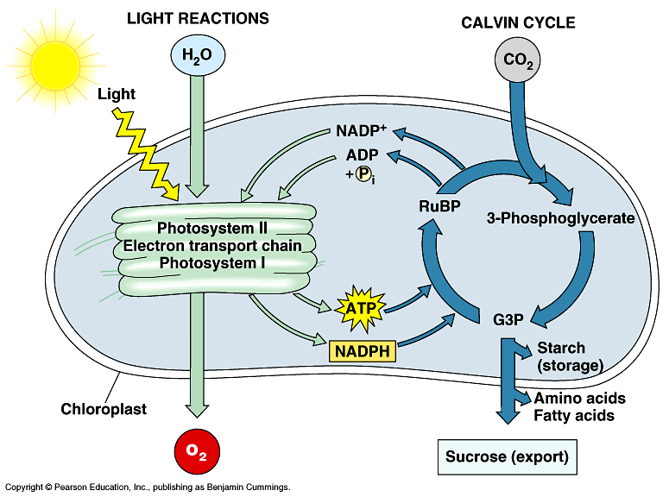This process is broken down into two components: the **light-dependent reactions** and the **carbon-fixing reactions (Calvin cycle)**. These reactions occur within the chloroplasts, and are dependent on the pigments found in the chloroplasts.

Not all colors (or “wavelengths’) of light are strongly absorbed by chlorophyll (the green pigment) and carotenoids (the yellow and orange pigments), the pigment molecules that occur in chloroplasts. Only the photons of certain wavelengths are efficiently absorbed by the photosynthetic pigments, leading to the formation of carbohydrates and oxygen. Photons that are not absorbed by the pigments are not used in photosynthesis.

The algae are a group of organisms (most of which are photosynthetic) that have a simple body construction (no organs or vascular tissue). Algae have reproductive structures that are not protected by layers of cells.

At one time, algae were placed in the kingdom Plantae, but they now are divided up among several major groups. Algae are classified on the basis of their pigmentation, cell wall structure, chemical composition of their stored carbohydrates, and molecular features. Within a taxonomic division, some species may be microscopic and others may be macroscopic. Although most algae live in freshwater or marine systems, some can also be found in terrestrial habitats (i.e. look for green discoloration on buildings/concrete).

Algae are responsible for at least half the carbon dioxide fixation on earth. Through carbon fixation and photosynthesis, algae greatly increase the oxygen concentration in their environments. You will observe this happening in the demonstration today in lab

“Algae” is a **polyphyletic** group. This means, organisms called “algae” are not from just one evolutionary group. Here are the major groups called “algae.”

|  |  |  |  |  |
| --- | --- | --- | --- | --- |
| Clades | Other names | Size | Examples | Notes |
| Euglenoids |  | Micro-scopic | *Euglena* | Autotrophic and heterotrophic |
| Dinoflagellates | Pyrrhophyta | Micro |  |  |
| Diatoms | Bacillariophyta | Micro |  |  |
| Brown | Phaeophyta | Macro | *Laminaria,  Fucus* |  |
| Golden | Chrysophyta | Micro |  | Facultatively heterotrophic |
| Red | Rhodophyta | Macro | *Polysiphonia Chondrus* |  |
| Green | Chlorophyta | Micro & Macro | *Ulva, Spirogyra, Chlamydomonas* |  |

## 2603A — ALGAE

**Euglenas** are in the division Euglenophyta. These algae are often flagellated, can have a red eyespot, and are enclosed in a flexible wall termed a pellicle.

**Diatoms** are in the division Heterokontophyta. Diatoms have silica cell walls, and their reserve storage material is oil, rather than starch. Some species exist as unicells and others as filaments consisting of individual cells linked together. During asexual reproduction, the original top half of a diatom forms a new bottom half, and the original bottom half acts like a top half, with a new bottom half being formed. See illustrations in your book for details. Diatoms have no flagella except when reproducing sexually.

Label the brown algae diagrams.

Airbladder

Frond

Midrib

Receptacle

Stipe

Holdfast

Label the brown algae diagrams.

Airbladder

Frond

Midrib

Receptacle

Stipe

Holdfast

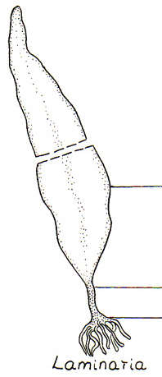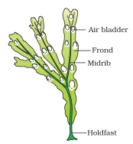

Laminaria

_________________

_________________

__________________

Fucus

__________________

__________________



Laminaria

**Phaeophyceae: Brown algae**

***Fucus*** sp. is an alga with a complex form in Phaeophyceae, the brown algae. Note the blade with midrib, holdfast, and receptacles (at the tips) containing gametangia, which are reproductive. Look at a cross section through the receptacle and view the sex cells; draw what you see.

***Laminaria*** sp. is another brown alga that can grow over 2 meters in length (one common Rhode Island species is branched, the other is unbranched). Examine the blade, stipe, and holdfast of this kelp. Label the three parts on the picture given.

**Rhodophyceae: Red algae**

***Polysiphonia*** sp.is a marine macroalga in the red algal division, the Rhodophyta. This genus is commonly found on Rhode Island shorelines.

***Chondrus crispus*** is a red alga commonly found in the low intertidal in Rhode Island and used commercially. Draw the gross morphology of this alga and do a cross section of the tissue to see the photosynthetic cortex and the colorless medulla.

***Grateloupia*** ***turuturu*** is a blade-forming red alga that was first found in Rhode Island in 1996. If you examined a cross section, you would see how few cell layers make up the unique medulla this exotic, invasive alga.

***Palmaria palmata*** is another blade-forming red alga. This species has a very different internal structure than ***Grateloupia.***; Examining a cross section would show you the contrast between the two species.

**Chlorophyceae: Green algae**

***Chlamydomonas*** sp**.** is a motile, unicellular green alga. View through microsope.

**Desmids** are non-motile green algae also in the division Chlorophyta. The Chlorophyta possess the pigments chlorophyll a and b and store starch. These two characteristics are found in land plants and infer a green algal ancestry for all terrestrial plant species. Desmids are unicellular, but often appear to be composed of two cells because of the constriction of the single cell.

***Spirogyra*** sp. is a green alga that forms unbranched filaments. Microscopically examine these filaments and locate their spiral chloroplasts. The structures within the chloroplasts are pyrenoids, centers of starch production and storage. If fresh samples of *Spirogyra* are available, prepare a wet mount of the alga and stain the slide with an iodine solution to see the purple color indicative of starch**.**

***Ulva*** sp. is a green alga that commonly forms blooms in the summertime in Narragansett Bay.   
Make a cross-section of this organism, commonly called “sea lettuce,” and examine the two cell layers that make up its thallus.

Draw a picture of an example species of MACRO-ALGA from each of the three main algal groups.

**Phaeophyceae** **Rhodophceae** **Chlorophyceae**

**B— Examine release of oxygen in light-dependent reactions**

**Converting light energy to chemical energy**

The photosynthetic process can be examined as two main reactions: the light-dependent reactions (the “photo” part of photosynthesis) and the carbon-fixing parts of the reaction (the “synthesis” part of photosynthesis.) During the light dependent reactions, electrons are energized by the sun. This energy is captured as chemical energy in the form of ATP and NADPH. In these reactions, water molecules are split and oxygen is released. We will examine the light-dependent reactions occurring in our lab.

The energy molecules formed during the light-dependent reactions are used in the carbon-fixing reactions. In these reactions, carbon, from carbon dioxide molecules, are used in the formation of glucose.

**B1: Predictions**

**Predict what amounts of oxygen you expect to see collecting in the inverted test tube above clear and blackened funnels placed over green plants placed in water.**

**B2: Test predictions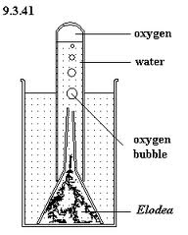Procedure to measure the oxygen released by plants**

1. Weigh out two bunches of 3 healthy leaves of fresh spinach. Record the weights. Try to select leaves of approximately equal weights.
2. Place the spinach leaves under your two funnels, one clear and one darkened, each set in bicarbonate water. (Water with added sodium bicarbonate (NaHCO3) is available from by your TA. NaHCO3 provides readily accessible CO2.)
3. Place a bicarbonate-water filled test tube over the funnel. Be sure no gas is in test tube to start.
4. Keeping temperature consistent between two setups, examine amount of oxygen collected after 1hour.
5. Record data. Share data with class. Determine if there were consistent differences between the two setups*.   
   Picture from: www. uq.edu.au*

**C — Examine absorption spectrum of algae**

In this exercise, you will measure the absorption of different wavelengths of light by the pigments from three different algal species using a spectrophotometer. You will identify which wavelengths are effectively absorbed and which are not.

**C1: Predictions**

**Predict what wavelengths you expect to see peaks and valleys for each sample.**

**C2: Test predictions**

**Procedure to measure the absorption spectrum of a variety of algal species**

1. Weight out 5g of fresh spinach OR algae. Grind samples into small pieces in a mortar with   
10mL of 95% ethanol. Grind thoroughly, extracting the chlorophyll pigments from the chloroplasts.

2. Place a 50mL flask below a funnel lined with filter paper. Pour the ethanol and sample slurry into the funnel lined with filter paper. Once your filtered spinach-ethanol has dripped through, check your pigment concentration again the demo tube your TA has set up for comparison. If necessary, dilute your slurry by adding additional ethanol.

3. Fill one cuvette 3/4 full with 95% ethanol. This is your “blank.”

4. Fill one cuvette 3/4 full with filtered sample.

5. Following the instructions next to the spectrophotometer, zero out the spectrophotometer with the “blank” ethanol cuvette, and then measure the absorption of the samples.

6. Measure the absorbance of extracts from three samples from 400 -700nm.   
Measure the absorbance at **10nm** intervals. In the peak ranges, determine the highest absorbance peaks with more detailed measurements. Enter data on the next page.

**At the end of measuring samples on the spec**

1. Put contents of ground sample material and remaining EtOH into trash.

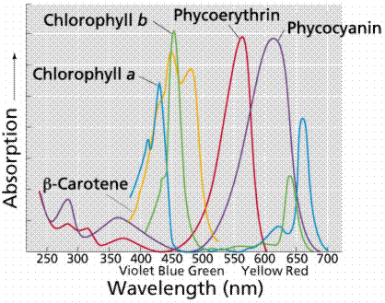2. Wash in sink and leave to dry on paper towels next to your spectrophotometer:   
 — mortar and pestle  
 — cuvettes  
 — disposable pipettes

**C3: Assess results compared to predictions**

Assess results in lab report.   
Follow rubric from TA.

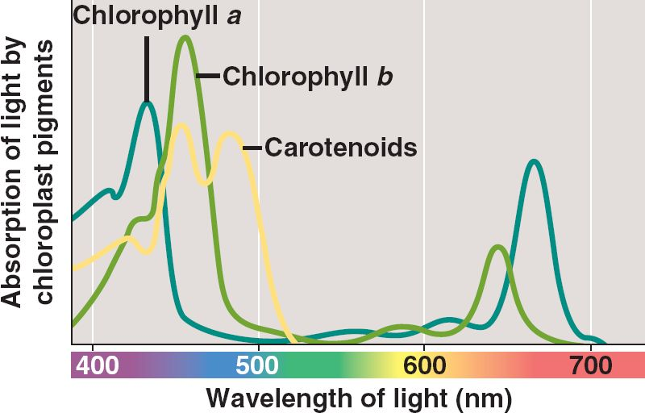**Fill out the table using data from the spectrophotometer.**

*www.instructables.com* and *http://bio1903.nicerweb.com*

|  |  |  |  |
| --- | --- | --- | --- |
| **Wavelength (nm)** | **Absorbance Spinach** | **Abs _________** | **Abs ______________** |
| **400** |  |  |  |
| **410** |  |  |  |
| **420** |  |  |  |
| **430** |  |  |  |
| **440** |  |  |  |
| **450** |  |  |  |
| **460** |  |  |  |
| **470** |  |  |  |
| **480** |  |  |  |
| **490** |  |  |  |
| **500** |  |  |  |
| **510** |  |  |  |
| **520** |  |  |  |
| **530** |  |  |  |
| **540** |  |  |  |
| **550** |  |  |  |
| **560** |  |  |  |
| **570** |  |  |  |
| **580** |  |  |  |
| **590** |  |  |  |
| **600** |  |  |  |
| **610** |  |  |  |
| **620** |  |  |  |
| **630** |  |  |  |
| **640** |  |  |  |
| **650** |  |  |  |
| **660** |  |  |  |
| **670** |  |  |  |
| **680** |  |  |  |
| **690** |  |  |  |
| **700** |  |  |  |

## *Lab 4*: PLANT DIVERSITY

**Purpose**

1. Introduction to major types of plants. This overview will give some evolutionary context to the upcoming Bio 104 labs, which will concentrate on the anatomy and physiology of angiosperms in particular, and then comparatively examine other groups of green plants.
2. To observe the alternation of generations by examining the sporophytes and gametophytes of mosses and ferns.
3. To observe other spore-bearing and seed-bearing vascular plants.
4. To collect examples of these four plant groups and create a descriptive page displaying the plants
5. To examine lichens as a symbiosis of two organisms

**Introduction**

Plants are multicellular photosynthetic eukaryotes. They participate, through photosynthesis, in producing the energy that enters drives ecosystems as well as a source of the oxygen that is used in cellular respiration. The Viridiplantae, or green plants, are a single family that is made up of four groups of land plants as well as the closely related green algae.

The following phylogenetic tree displays these major groups of plants and their evolutionary relationships as deduced from morphological data of living and extinct (fossils) plants as well as DNA sequence data. This tree represents the current understanding of the evolution of green plants.

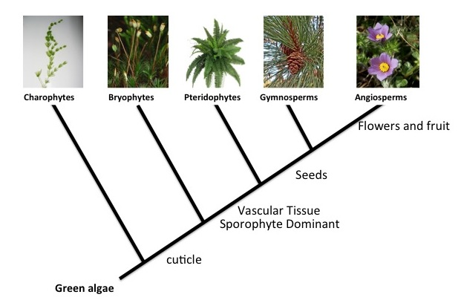

Fig 1. Phylogenetic tree showing major evolutionary advanced of land plants.

Today’s lab will examine the five major groups identified by this phylogenetic tree:   
1) Green algae and Charophytes  
2) Bryophytes - Mosses (liverworts & hornworts) non-vascular plants  
3) Ferns and other vascular seedless plants  
4) Gymnosperms - Pines (and other naked-seed plants)  
5) Angiosperms (flowering plants)

Each group on the phylogenetic tree is associated with adaptive changes representing over 475 million years of evolution. The major features in these groups are associated with adaptive changes associated with the transition to life on land. Living on land plants need to prevent water loss and acquire nutrients. The development of cuticle and pores allowed for plants to exist on land, independent of water. This innovation gave rise to the mosses and similar plants.

Green plants could not grow tall without the ability to transport material throughout the plant and the ability to remain rigid enough to not fall over. The development of vascular tissue gave rise to plants that can defy gravity and wind, as well as transport water to tissues in the air and to transport carbohydrates to tissues away from energy capturing mechanisms. The development of vascular tissues began the rise of ferns and other vascular plants.

Gymnosperms and Angiosperms developed more complex vascular tissues and reproductive structures that make them better suited to life on land.

Fig 2. History of the earth – timeline of the evolution of plants and animals.

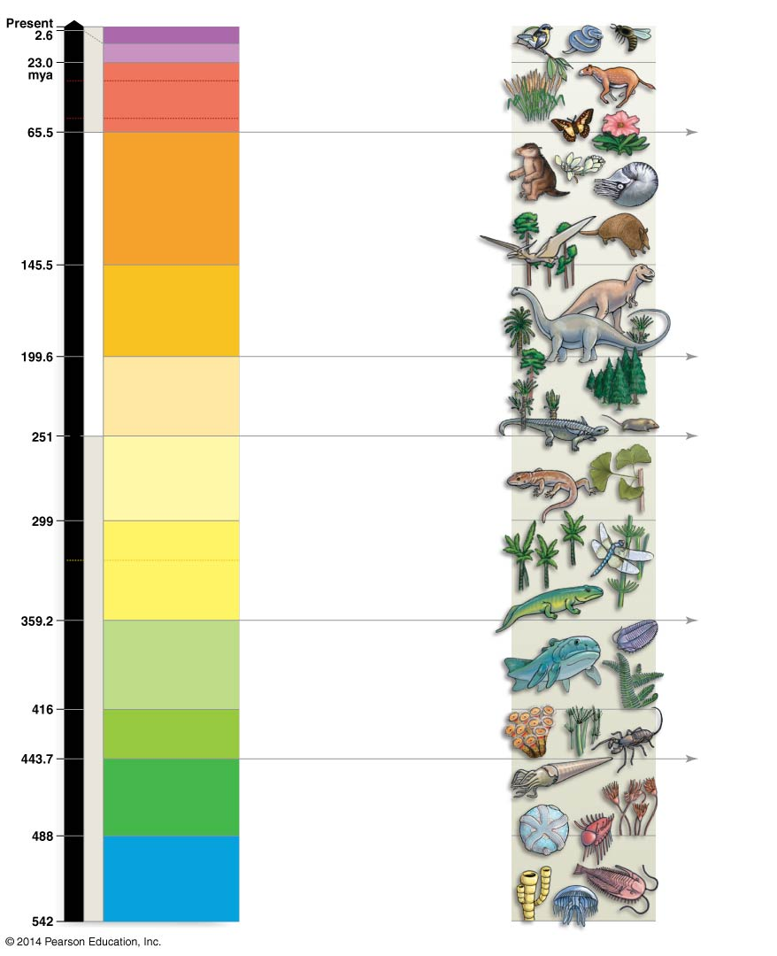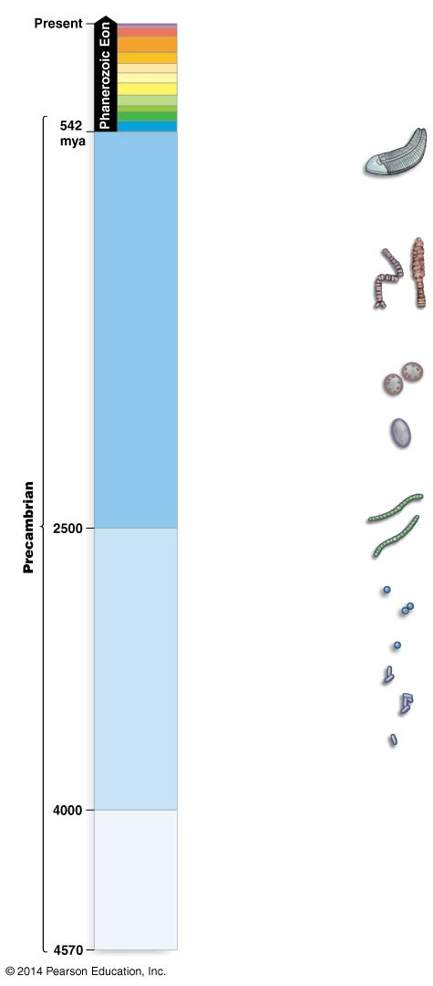

First bryozoans “moss animals”

Arthropods diversify

First fish and insects

First amphibians

First amniotes

(vertebrates   
 with eggs)

Dinosaurs and first mammals

First placental mammals

First bees and ants

First whales and apes

CENOZOIC

66mya - present

Oldest pollen

MESOZOIC

251 - 68 mya

First land plants

First ferns

and vascular plants

First seed plants

First nectar

drinking insects

First angiosperms

PALEOZOIC

542 -251 mya

Precambrian 4570 -542 mya

mya

**Bryophytes**

The dominant phase of Bryophytes (common example: mosses) is the haploid gametophyte plant. The sporophyte, the diploid phase, consists of the stalk and capsule. In this capsule (=sporangium), meiosis takes place and haploid spores are produced.

Operculum (covers Peristome)

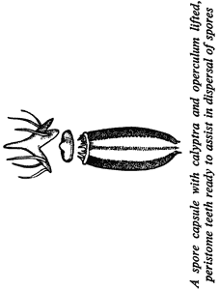

Calyptra  
 (covers Operculum)

Spores Inside

Peristome (Opening)

**Pteridophytes**

In Pteridophytes (ferns and other fern-like vascular plants), the diploid sporophyte phase is dominant. In these plants, haploid spores are produced by meiosis in sporangia on the underside of the fern fronds or in the strobili of the fern allies. The haploid gametophyte phase of these plants is free living, small, and infrequently found in the field

The diploid sporophyte is also the dominant phase in the Gymnosperms and Angiosperms. The haploid gametophyte is much reduced in these plants and does not live independently of the sporophyte. The gametophyte phase consists of only a few cells that reside within a cone or flower, although each female gametophyte of some gymnosperms may include about 2000 cells.

This sequence of examining mosses, ferns, conifers, and flowering plants is an attempt to duplicate the evolutionary path of plants as they colonized the land. The earliest plants that dominated the landscape emphasized the haploid gametophyte stage with a reduced diploid sporophyte stage. The flowering plants that now dominate the earth emphasize the sporophyte, and the gametophyte stage is only a pollen grain and an embryo sac within an ovule.

|  |  |  |  |  |  |  |
| --- | --- | --- | --- | --- | --- | --- |
|  | **Common name** | **Dominant Phase** | **Vascular Tissue** | **Seeds** | **Flowers** | **Other notes** |
| **Bryophyta** | Mosses | Gametophyte |  |  |  | Male & Female gametophytes |
| **Pteridophyta** | Ferns and fern-like plants | Sporophyte | **yes** |  |  | Free living thallus  (= gametophyte) |
| **Gymnosperm** | Pines, evergreens, cycads | Sporophyte | **yes** | **yes** |  | Reduced gametophyte, “naked seed” |
| **Angiosperm** | Flowering plants | Sporophyte | **yes** | **yes** | **yes** | Reduced gametophyte, monocots & dicots, “covered seed” |

**Alternation of Generations in Land Plants**

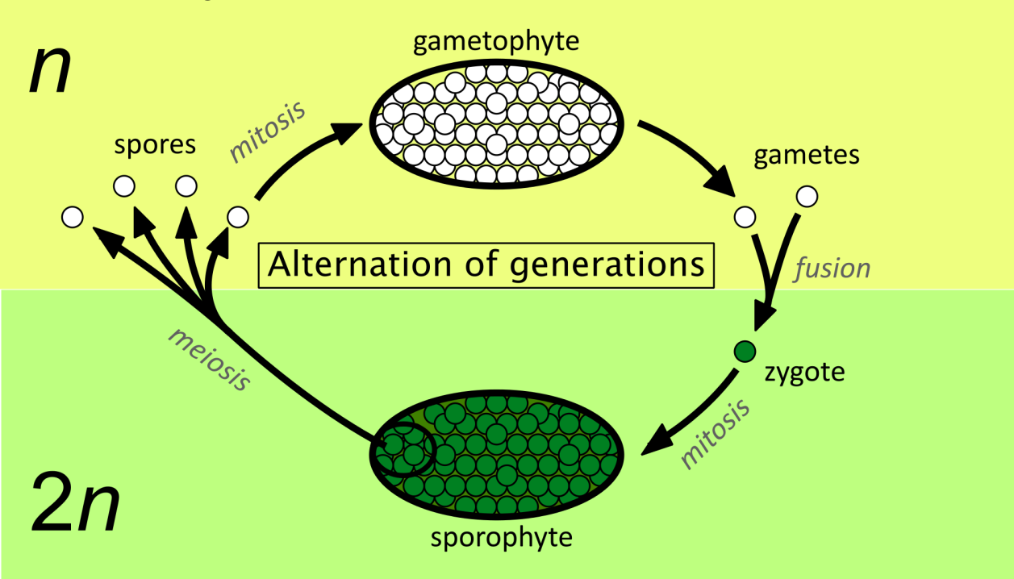

**COMPLETE the definitions below by circling the correct options.**  Then, learn the terms.

**Gametophytes =** a **haploid — diploid** multi-cellular life stage that produces **spores or gametes**

**Sporophytes =** a **haploid — diploid** multi-cellular life stage that produces **spores or gametes**

**Haploid Phase =** phase of multicellular generation of plant where the cells in the plant   
have a **single — two sets**  of **unpaired — paired** chromosomes

**Diploid Phase =** phase of multicellular generation of plant where the cells in the plant   
have a **single — two sets**  of **unpaired — paired** chromosomes

**Spore =** a **haploid — diploid** cell that divides through **mitosis — meiosis** to become  
 **gametophyte — sporophyte**  multi-cellular phase of the plants’ life cycle

**Sporangia =** a receptacle where **haploid spores — haploid gametes** are created. Sporangia are found on the **gametophyte — sporophyte** multi-cellular plant.

**Archegonia — NEED TO FINISH THIS**

**Anteridia**

**Protonema**

**Frond**

**Bryophyta**

**Pteridophyta**

**Gymnosperm**

**Angiosperm**A — Bryophyta (Mosses)

Observe the gametophytes and sporophytes under a stereomicroscope. Mount a moss leaf in water, and locate the chloroplasts. Note the thinness of these leaves.

Examine some spores by crushing the capsule on a microscope slide.   
Draw **FRESH SPORE CAPSULE** and **PREPARED SPORE CAPSULE** slide.

Label: spore capsule (sporangium), peristome, operculum, and spores.

**Live spore capsule Spore capsule prepared slide**

**When the spores germinate, do they give rise to the sporophyte or gametophyte stage?**

**Are the spores haploid or diploid?**

## B — Pteridophyta (Ferns and fern-like plants)

**B1) Ferns.** Examine the potted fern plants. The stems, or **rhizomes**, bear large **fronds** (the leaves). Locate the clusters of **sporangia** on the undersides of the more mature fronds.

Examine the prepared slide of the fern gametophyte under low power of your microscope. Archegonia (in which eggs are produced) should be centrally located on this gametophyte, and the antheridia (structures in which sperm are produced) are formed around the perimeter. **Draw the fern gametophyte and identify: thallus, archegonia, and antheridia.**

What are the functions of the antheridia and archegonia?

Some ferns may grow over 30 feet tall (e.g. tree ferns in New Zealand). The largest moss, though, seldom reaches more than a few inches above its substrate. Suggest a reason for the difference in maximum height between the two.

**B1) Ferns-like plants.** Examine potted sporophytes of *Psilotum* sp., *Selaginella* sp., *Lycopodium* sp., and *Equisetum* sp. Locate the spore-bearing structures, if present, and record where you find them.   
**Are the plants that you are examining diploid or haploid?**

## C — GYMNOSPERMS

## D — ANGIOSPERMS

Throughout the lab are examples of conifers and flowering plants. Both of these are seed bearing vascular plants. **In what ways do they differ?**

## LIFE CYCLES

Using the diagrams provided, **compare** and **contrast** the life cycles of mosses, ferns, conifers, and flowering plants. Note the **similarities** and **differences** among them, and **record** your observations.

Write the names of the *all* plant groups examined today that match the following questions.

PLANT GROUPS viewed today:   
 (B) Bryophytes, (P) Pteridophyte, (G) Gymnosperms, and (A) Angiosperms.

1. What group does not have a vascular system?

2. What groups have a vascular system?

3. In what group is with the gametophyte dominant ?

4. In what group is with the sporophyte dominant?

5. The dominant stage of what group is haploid?

6. Plant group with seeds but no fruits

7. Plant groups with flagellated sperm

8. What group has flowers?

9. What group has fruits?

10. Which groups reproduces by spores?

11. Which groups photosynthesize?

12. Which group lacks xylem & phloem?

13. Which groups produce pollen?

14. Which groups have seeds?

15. Which groups form ovules

**Bryophytes, Pteridophytes, Gymnosperms and Angiosperms – Example plants**

On a sheet of heavy cardstock paper, for each of these four major groups,

1. Collect an example of each from outside on walk with TA.
2. Tape down an example of each collected.
3. List one or two common names of example plants
4. List the dominant phase. List if plant groups have: vascular tissue, seeds, flowers

Bryophyte

Dominant phase:

vasc tissue: Yes or no  
seeds: Yes or no   
flowers: Yes or no  
Common name:

Angiosperm

Dominant phase:   
vasc tissue:

seeds:

flowers:

Two categories  
 Monocots Dicots

Common names:

Gymnosperm

Dominant phase:

vasc tissue:   
seeds:   
flowers:   
Common names:

Pteridophyte

Dominant phase:

vasc tissue:   
seeds:   
flowers:

Common names:

**FUNGI AND LICHENS**

Most fungi are decomposers, gaining their nutrients by decaying dead plants and animals, thus recycling nutrients back to the environment. Fungi can produce a large array of enzymes, proteins that break the chemical bonds in the food upon which the fungus is feeding. A by-product of fungal respiration is CO2. Some fungi are directly beneficial to humans. The fungus *Penicillium* *sp.* is the source of the drug penicillin and is also used to make blue cheese. Mycorrhizal fungi form beneficial symbiotic relationships (a.k.a. mutualism) with the roots of 90-95% of all plants. These fungi assist the plants in obtaining phosphorus and other nutrients from the soil in exchange for sugars that the plant provides to the fungus.

Lichens are a group of organisms consisting of mutualistic relationships between a fungus and a photosynthetic species (called a **photoautotroph**). The photoautotroph can either be a eukaryotic green algae or a photosynthetic prokaryote (once called “blue-green algae”) and provide carbohydrates formed by photosynthesis to the fungus. The fungus protects the photoautotroph from excess sunlight and prevents damage due to rapid dehydration and uses the carbohydrates in cellular respiration and growth.

**Terms:** Define and learn the following terms. Use your manual or class text to help you.

**Fungi**

**Lichen**

**Hyphae**

**Mycelium**

**Mutualistic relationship**

Fungi

Land plants

Algae

Animals

**Fungus1**. Examine and draw a fresh mushroom of the genus *Agaricus* and identify the **cap**, **stipe** and **gills**.

**Fungus2.** With the compound microscope, examine a prepared slide of the cap of a *Coprinus* mushroom. **Identify the parts on the slide picture below. (Label parts: cap, gills, stalk)  
Locate the spores being produced on the surface of the gills.**

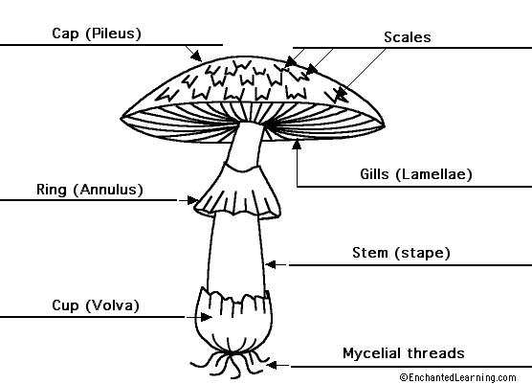

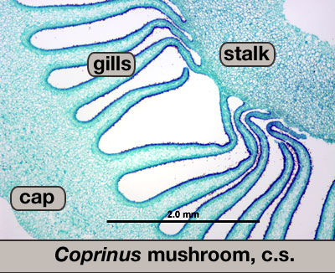

**Fungus3. Fungi Causing Wood Decay**

Fungi that are able to decay wood do so by secreting enzymes that dissolve the walls of the cells in the wood and then growing new hyphae that extend farther into the wood. After the wood has been decayed for some time (months to years), mushroom-like structures are formed by the fungi on the outside of the wood. Many of these mushroom-like structures are shaped like small shelves or brackets and have small pores on their lower side. Astronomical numbers of spores are formed inside these pores and are released to the air, carried by wind currents to other trees.

1. Examine the pieces of decayed and intact wood. Poke each with a dissecting needle and note the difference in hardness. Why is the decayed wood softer? Why is the decayed wood lighter than the intact wood? Look for bracket fungi on the branch.

2. Examine one of the large bracket fungi. Notice the tiny pores. For brackets that are attached to trees for several years, a new layer of pores is formed each year. You can tell the age of the bracket by counting how many layers of pores there are. **Draw one of the bracket fungi showing the layer of pores**. Draw an example of bracket fungi that is 5 years old.

## C — LICHENS

Lichens are unique organisms that rely on symbiotic relationship of two kingdoms for their existence; lichens are associations between a fungus and green alga or cyanobacterium. The fungus provides protection from desiccation for the alga or cyanobacterium. The alga or cyanobacterium provide sugars from photosynthesis for the fungus.

**C1.** In lab, you should be able to see different types of lichens in three characteristic forms. Draw examples of these three types of lichens and identify these different morphologies.

1. Fruticose (branched and scraggly)
2. Foliose (leaf-like)
3. Crustose (crusty, paint-like)

**C2.** Draw examples of these three types of lichens and identify these different morphologies.

Why might some be more beneficial than others??

Where might you expect to see different lichens growing?

**C3.** Examine a prepared slide of lichen. In the picture below, identify and label the numerous,   
thick-walled **fungal hyphae** and the single, green **algal cells.**

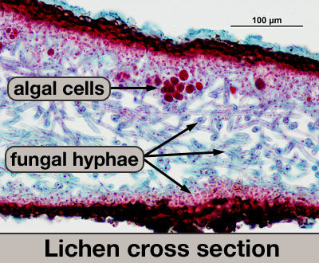

# 

Note: This is a figure **legend**

*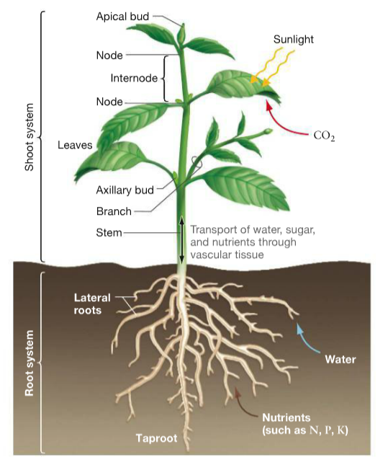Lab 5:* **Plant Structure  
 and Function**

**INTRODUCTION:** In an earlier lab, you examined plant diversity. Although the diversity of plants can be impressive, they all share a few common needs. In order to grow and reproduce, plants need to obtain nutrients, water, sunlight, and carbon dioxide for photosynthesis. The figure below highlights some of the major structures of a plant that are used to acquire and store the necessary resources for the main processes used by plants, photosynthesis. Use this figure to recall and record the basic function of each plant structure in the table below.

**Figure 37.1 (p. 732)**

Table 1.

1. 1.

|  |  |  |
| --- | --- | --- |
| **System** | **Structures** | **Functions** |
| Root System | Taproot | 1. Anchors the plant  2. Takes in water from soil  3. Takes in nutrients from the soil  4. Conducts water and nutrients to the shoot system.  5. Stores material produced in the shoot for later use. |
| Lateral Roots |
| Shoot System | Nodes | 1. Harvest light  2. Harvest carbon dioxide from atmosphere  3. Produces sugars that can be provided to cells in throughout the plant and to the root system for storage. |
| Leaves |
| Buds  Axillary  Apical |
| Stems |

**MODULE I: Descent with Modification in Plants**

Objective: To describe variations in the structure of plant organs (modified stems and leaves) and hypothesize how those variations relate to their functions.

**Introduction**:

Every day as you walk across campus, you can see several different types of plants. All plants have similar structures (leaves, stems, roots, etc.) and yet they also look unique in some way- either varying in large ways between species (a Chestnut tree vs turf grass) or in more subtle ways between individuals of the same species (i.e. longer stems, deeper roots). A major question posed by biologists (indeed one asked by Darwin himself) is “What is the cause of this variation?” Do similar structures perform the same basic functions in different plant species? How do variations in structure impact their functions?

The variation you are observing is a result of natural selection. **Natural selection** is the process by which certain heritable traits- that increase an organism’s ability to survive and reproduce- become more common in a population over time. Natural selection can result in adaptation to different environmental conditions. This leads to *“descent with modification”* – which occurs as variations of the same structure in related plants enable them to adapt to unique environments.

During today’s lab we will examine how different plant species have developed modified stems and leaves in order to hypothesize how variations in stem and leaf structure relate to differences in function.

1. Below is a list of modified stems and leaves. In the lab, you will find an example of each of these modified stems or leaves. Fill in the modified stem or leaf information in Table 2 below.

Table 2.

2.

|  |  |  |  |
| --- | --- | --- | --- |
| Modified Stem/Leaf | Description | Example | Function/Adaptation  — student hypotheses |
| Rhizome |  |  |  |
| Stolon |  |  |  |
| Tuber |  |  |  |
| Water-storage structure  Water storage structures  2. |  |  |  |
| Rosette |  |  |  |

1. Check with your TA that you have correctly matched the modification and example.   
   Write a hypothesis about how each modified stem helps the plant adapt and function in   
   the environment where it is found. Write your brief hypotheses in Table 2.

**Now let’s take a closer look at each of these modifications.**

1. A **rhizome** is an underground, horizontal stem. The example you have examined is American beachgrass, which is a common species found on sand dunes in North America. The rhizomes of American beachgrass are broken apart during storms when waves attack the dunes. Fragments of the rhizomes (a few inches to more than three feet long) are carried into the ocean, transported in longshore currents (that travel parallel to the shoreline) and later are deposited on new sandy beaches. The rhizomes sprout new roots and stems and establish a new plant. Many species of grasses and ferns (as well as some other plants) produce rhizomes.
   1. Examine the rhizomes of the American beachgrass again and locate the nodes and internodes (the long sections between the nodes).  
       **Draw the rhizome and label:** leaves (if present), lateral buds, growing shoot, old roots, new roots, node and internode. Clearly identify where roots originate.
   2. Based on your drawing above, what is the difference in function of a node and an internode?
   3. Why are rhizomes considered to be stem tissue?
   4. *Spartina alterniflora* is a common cordgrass that grows in coastal wetlands. Your TA will show you some images and herbarium specimens of this plant. It is an example of another plant that has rhizomes. Ecologists such as Earl Davey, at the Atlantic Ecology Division of the Environmental Protection Agency, have pioneered use of computed tomography (aka “CT scans” used in medical applications) for analysis of plant roots and rhizomes. Following are images of two cores that were collected from local salt marshes in Warwick (Gaspee Point). The large white structures are rhizomes.   
      Are there any similarities between the rhizomes in this plant and the American beachgrass?
   5. After further investigation do you think your hypothesis of the function of rhizomes in Table 2 is correct? Why or why not? If not, then revise your hypothesis?



Figure above. These cores were part of an experiment that was testing impacts of soil warming on marsh plants. The white structures are rhizomes. The core on the left was from a control plot (ambient temperature) while the one on the right is from a plot that had an experimental warming tent placed over the plants. (The tent was transparent so did not block light to the plants).   
  
What difference do you see in the rhizomes between the control and warmed cores?   
  
Why might this difference in rhizome density have occurred?   
  
How would this difference affect the ability of the warmed plants to grow?

1. Stolon: **Stolons** are also horizontally growing stems that produce adventitious roots that develop when in contact with soil. Observe the strawberry plant and/or spider plant , answer these questions:
2. Rhizomes and stolons are similar in that they are both horizontal stems. How do they differ?
3. What is the function of stolons?   
   Does this match your hypothesis on the Table 2?
4. Rosette plants: Some plants have stems that do not elongate much (except when flowers are produced). In these plants the leaves are produced very close to the ground where the leaves attach to the stem. This type of growth form is called a "rosette."
5. Identify the junction of root, stem, and leaves. About how long is the stem of the carrot plant?
6. What is the advantage of having leaves very close to the ground?   
   Does this relate to the function you hypothesized in Table 2?
7. Tuber: A white potato is a modified stem called a tuber that forms at the end of a rhizome. We know that a potato is a modified stem because stems have axillary buds. The axillary buds on potatoes are called "eyes."
8. Locate the eyes on a potato. Your lab instructor will show you how to visually connect the eyes, like completing a dot-to-dot puzzle. Note the helical arrangement of the eyes, much like the arrangement of leaves on stems of many plants. Examine the leaf scars below each axillary bud.
9. Why can potatoes be planted using pieces of the tuber that have an eye?
10. Tubers function as a storage organ. What do you think they store?   
     Does this match your hypothesis in the table above?
11. Water storage stems (Cactus): Carefully (!) examine the cactus plant. The leaves are called spines. All photosynthesis occurs in the stems, the fleshy part of the cactus. Certain cells in the stem store water after rainfall, allowing the plant to survive during the long, arid conditions typical of deserts.
12. Besides support what is the other primary function of cactus stems?
13. What is the advantage to a cactus plant of not having photosynthetic leaves with blades?
14. What is the disadvantage of not having photosynthetic leaves with blades?

**Summary**

1. Based on your observations today of variation in plant stems and your understanding of natural selection, explain why is variation in plant structures important?  
    (Review at least 3 examples from the lab exercises and use them to answer this question).
2. Many plant organs besides stems vary. Name another structure of a plant that is often modified and explain how it relates to the function.

**MODULE II**: **Plant tissues and cells**

Learning objectives:

1. To identify where the major tissue groups are found in a plant and recall their functions.
2. To identify which specialized plant cells are a part of each tissue system.

Plants adapt to unique environments in several ways. The modifications in stems that you examined in module I are just one example. Such adaptations are possible largely because plants (like animals) are complex organisms with multiple tissue types. These tissues differ from each other in terms of structure and can therefore serve a range of important functions throughout the body of these organisms.   
   
Record the three major tissue types in plants and the functions of these tissues.

Table 3.

2.

|  |  |
| --- | --- |
| Tissue types in plants | Functions |
|  |  |
|  |  |
|  |  |

*(Hint: You can see the three major tissue types listed in the figure below).*

Similarly, each tissue type is comprised of specialized cells that are structured in ways that relate to their function in tissues. Just as a skin cell on your fingertip is unique from a bone marrow cell, there are major differences between cells in different parts of a plant. And these structural differences relate to the functional roles of the cells as well as the tissues they comprise.



**Functions of plant tissues**

The figure above illustrates where major tissue groups- Dermal, Ground, and Vascular tissues- are found in a simple (generalized) plant. Note that they are all present in each plant organ (leaf, stem, root), but they vary in size and arrangement.

1. What function does dermal tissue perform?   
     
   Why might the dermal tissue layer be so thin in leafs compared to roots?

Stomata are openings found on the top and bottom of leaves. Stomatal pores are created by dermal guard cells opening and closing to allow gas exchange necessary for photosynthesis.   
Hypothesize:  
Write whether you believe there will be more stomata on the top or bottom of leaves and why.

Test your hypothesis. Get TWO ~1x1cm pieces of Tradescantia (a purple& green leaved monocot).

Apply a layer of nail polish on the top of one piece and to the bottom of the second. Let polish dry (about 5 min). While waiting, label a microscope slide, one side is Top, the other Bottom.

When polish is dry, firmly apply clear tape to the polished leaf surface. (Have one end of the tape folded onto itself to use as a “handle.” Carefully, pull the handle to peel the tape with polish off the leaf. Attach tape to the appropriate side of your labeled slide. Examine your slide under compound scope. Record below the number of stomata in field of view for the top and the bottom of leaf.

Number of stomata counted in three views of top and bottom of leaf samples.

Table 4.

2.

|  |  |  |
| --- | --- | --- |
|  | Top of leaf | Bottom of leaf |
| View 1 |  |  |
| View 2 |  |  |
| View 3 |  |  |

Which side has more stomatal openings ? ________ Does your data support your hypothesis?________

Why do you think this is so?

1. Examine the celery stalk soaking in food coloring. What happened to the colored water?   
     
   What type of tissue is involved here?

Now let’s look at tissue samples of the monocot *Zea mays* (corn) and the dicot *Helianthus sp. (*sunflower).

1. Based on your observations, describe how the stem tissues differ from the root tissues.

Tissue arrangement similarities and differences

Table 5.

2.

|  |  |  |
| --- | --- | --- |
|  | Stem tissue | Root tissue |
| Monocot  *Zea mays* (corn) |  |  |
| Dicot  *Helianthus sp. (*sunflower) |  |  |

Look at prepared slides of monocot and dicot stem and root cross sections. Then label the following diagrams.

**STEM cross section  
 — Label:** monocot or dicot

Are vascular bundles (X & P)   
 **scattered** or **in circle**?

**Label:** Epidermis  
Vascular bundles  
Ground tissue

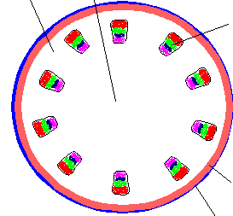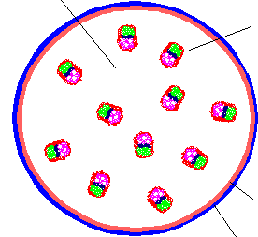

**ROOT cross section  
 — Label**: monocot or dicot

IS xylem and phloem arranged   
 **X-shape** or **in a ring**?

**Label:** Epidermis  
Cortex (ground tissue)  
Endodermis  
Xylem  
Phloem

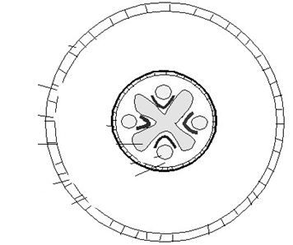

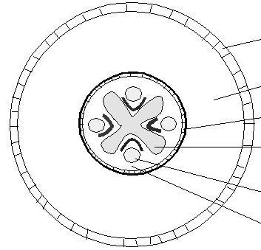

Look more closely within the tissues at specialized plant cells . (Here we are trying to help you to identify which specialized plant cells are a part of each tissue system..) Here we will focus on the plant stems.

1. Compare the prepared slides of stem cross sections *Zea mays* (corn) and *Helianthus sp. (*sunflower).

a.     Find the following cell types within each of the major tissues:

Vessel elements

Sieve tube members

Fibers

Epidermal cells

Parenchyma cells

b. Based on your observations, sort these cells into their respective tissue systems by writing their names in the table below. Add notes on the cell structures (shape, size) and location (central exterior).

Table 6.

2.

|  |  |  |
| --- | --- | --- |
| Tissue | Cell | Notes on cell structure/location |
| Dermal |  |  |
| Ground |  |  |
| Vascular |  |  |

**Summary**

Reflect back on the concept of “descent with modification” in plant organs (stems) from module I and use your understanding of the relationship between organs, tissues, and cells from this module (II) to answer the following question:

If all plant cells were identical, then could plants adapt to new environments? Why or why not?

*Lab 6***: Plant Growth and Differentiation**

**Purpose**

1. To identify the structure and the function of the major parts of Angiosperm seeds and seedlings.
2. Collect and analyze data to test the effect of temperature and light on seedling growth.

**Introduction**

*Review: Diversity of Plants*

 The phylogenetic tree below, which hopefully looks familiar to you, displays the major groups of plants and their evolutionary relationships. In previous labs you have examined some of the diversity of plants outlined in this phylogenetic tree. Today’s lab will focus on the plant growth- beginning with seeds: a unique reproductive adaptation that enabled the two most dominant groups of land plants to diversify- Gymnosperms and Angiosperms.

Charophytes Bryophytes Pteridophytes Gymnosperms Angiosperms

Seeds

**Fig 1.** Phylogenetic tree showing major evolutionary changes in land plants

The evolution of seeds was a major advance in facilitating the widespread dispersal of seed plants about 299 million years ago. Seeds are unique adaptations that enabled successful reproduction on land and away from moist environments. Seeds are a major advancement for a few reasons. Seeds contain the diploid embryo that can grow independent of the parent. Seeds contain nourishment for the young embryo. Seeds provide protection for the young embryo so it can disperse from the parent plant and germinate when favorable conditions trigger its growth.

Germination and growth

Seeds can be dormant for long periods of time. This is particularly common in seeds of plants that live in temperate climates. When conditions become favorable seeds begin to grow, **germinate,** to become young plants called seedlings. The first step in germination is the uptake of water (called **imbibition**). Next, the seed mobilizes stored reserves to allow it to begin to grow. The seed energy reserves are commonly stored as the carbohydrate starch, e.g. rice and wheat, but energy reserves are also stored as lipids/oils, e.g. coconut, palm. Amino acids are stored in seeds in the form of proteins and some seeds, like beans and soybeans, can contain very high amounts. The carbohydrates, lipids, proteins and other nutrients/minerals are stored in the seed in the embryonic leaves, called the **cotyledons**, or in another seed tissue called the **endosperm**. During germination these reserves are broken down and mobilized to be used for growth until the seedling can obtain resources on its own. Stored starches and oils are broken down and used to make energy through cellular respiration, and all types of resources are used as building blocks to produce new growth in the root and shoot of the young seedling.

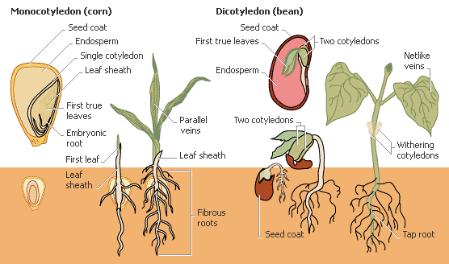

Epicotyl

Hypocotyl

www.biology.unm.edu/ccouncil/Biology_203/Images/FloweringPlants

The transition from seed to seedling is a crucial part of the plant life cycle. The parts of the embryo must grow, becoming larger and taking on different roles in the adult plant. For example the embryonic leaves, the cotyledons, are multi-functional organs. They can function to absorb nutrients from the endosperm as seeds develop, to store energy and nutrients during seed dormancy, and also to develop into photosynthetic leaves of the young seedling. Different families and even genera of plants vary in how they use their cotyledons.

Flowering plants (Angiosperms) are commonly divided into two major groups, monocots and dicots, based in part on the number of cotyledons in its seed. Records of people using this division date back to 600BC. However, we know that monocots and dicots do not represent monophyletic groups (species sharing one recent common ancestor). Also, plants listed as monocot or dicot may lack some of the ‘traditional characteristics’ of that group. With these caveats, the monocot and dicot groups can still be useful for classifying many of the plant species important for human use. We will compare examples from these two groups in this lab.

**Angiosperms — comparing differences in groups**

|  |  |  |
| --- | --- | --- |
|  | **Monocot** | **Dicot** |
| **Embryo** | One cotyledon | Two cotyledons |
| **Flower parts** | Multiples of 3 | Multiples of 4 or 5 |
| **Leaf venation** | Parallel | Reticulated |
| **Stem – vascular** | Scattered | In a ring |
| **Roots** | Adventitious | Taproot |

**Terms:** Define and learn the following terms.

Seed Seed coat

Cotyledons Embryo

Radicle Plumule

Epicotyl Hypocotyl

Monocot Dicot

**Lab overview:**

A) Seed structure: Following are instructions to help you learn about the parts of seeds and new seedlings. Label the seed diagrams to identify the different seed parts.

B) Seed function & seedling growth:

(1) Seedling data collection: Collect data on the growth of root, hypocotyl and epicotyl on the seeds grown under two different temperature conditions. Plot these data on a computer graph as part of assignment.

(2) Grow lettuce seeds in two tubes, under two contrasting light conditions: 5 seeds in the light and 5 seeds in the dark. Document the seedling growth on three days over one week. Collate data with class to create a data set as part of assignment.

C) Meristematic cell differentiation:

Clone a cauliflower plant using apical meristem tissue.

**Part A. Seed Structure**

A seed comprises a **seed coat**, an **embryo**, and may also contain **endosperm**. The seed coat is maternal tissue and serves to protect the embryo and endosperm from the environment as well as to aid in dispersal and timing of germination. The endosperm is a unique genetic entity that functions in nutrient storage in some seeds. The embryo represents a new diploid (2N) genetic individual. Embryos contain the embryonic shoot called the **plumule**, the embryonic root called the **radicle** and the region between the root and shoot known as the **hypocotyl** (‘hypo’ means ‘under’).

Dicots, as their name suggests, contain two cotyledons that are typically utilized for nutrient storage in the seed. In dicots, the **endosperm** is absorbed into the two cotyledons. Monocot plants contain only one cotyledon and it functions to absorb nutrients stored in the endosperm when the seed germinates.

1. Observe the demonstration by the TA of a coconut seed. All seeds contain the same basic parts but may have very different structures and patterns of growth. What part(s) of the seed is the coconut we eat?

2. Examine the variety of seeds on display. Look at the diversity of shapes and sizes.  
Mature seeds are typically very hard and become soft only after absorbing water.   
 Why is having a hard seed a good evolutionary strategy?   
  
  
What kinds of seeds might not need to ever become hard and dry?

In what kinds of environments might this strategy be more successful?

3. **The Dicot Seed**. Examine the dissected lima bean with a dissecting microscope.   
Note half the seed coat and one cotyledon are missing from picture below.   
Identify andlabel: **seed coat, cotyledon, radicle and plumule.**Which are parts of the plant **embryo**?

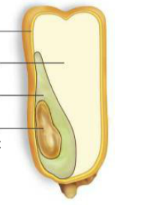

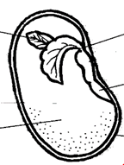

4. **The Monocot Seed.** Looking at a whole kernel of corn, identify the side of the kernel where you can see the whitish embryo through the seed coat. (The “seed” of corn is actually an entire fruit but we will discuss what parts are “fruit” in the fruit lab.)

Now, observe the dissected kernel of corn under the dissecting microscope. Identify the embryo axis (plumule and radical) that you can only see as a small torpedo shape in front of the monocotyledon.   
The TA has stained the corn kernel with iodine. Iodine reacts with starch grains and turns them dark bluish-purple. (Notice that the paper towel touching iodine will also turn blue. Starch is added to most paper products to give a smoother texture.) Look to see where the iodine has stained the kernel blue. Compare what you observe in the microscope to the diagram of a monocot seed provided above.   
Which part(s) of the seed were stained/ contain starch?

Label the **embryo axis** (plumule and radical), **cotyledon, endosperm** and **seed coat**.  
 Which are parts of the plant **embryo**?

**Answer the following questions regarding the monocot and dicot seeds.**

1. What is the main difference between the monocot and dicot seeds?
2. Are the cotyledons of the seeds photosynthetic?
3. Which makes up more of the seed- the endosperm or the embryo?
4. Are there visible/obvious leaves on the plumule in a corn ‘seed’?

**Part B. Seed Function — Germination and Growth**

1. **Identify monocot & dicot seed parts.** Seeds of beans and corn have been soaked in water and germinated for you. Examine seedlings. Identify and label below: **roots, cotyledon(s), and leaves**.

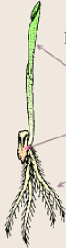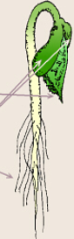





1. **Measure bean seedling growth under two different temperatures.**Once a seed has germinated, it begins to perform photosynthesis, as long as it has access to three main factors. These three main factors affect photosynthesis, and thus, affect the growth of plants.

The main factors affecting photosynthesis are: Light, Temperature, and Carbon Dioxide

**Light** – increasing light increases photosynthesis, up to the point where PS is limited by other factors.

**Temperature** – increasing temperature increases photosynthesis, up to the point where the enzymes reach their optimal working temperature (about 70F). Above that temperature, enzyme activity starts to decrease. Above 104F, these enzymes begin to lose their structural integrity and can no longer function.

**Carbon dioxide** – increasing CO2 concentration increases photosynthesis, up to the point where PS is limited by other factors.

In order to test this, we have grown bean seedlings at two different temperatures for about one week.  
**For the two temperature conditions, measure the length of the root, the hypocotyl and the epicotyl for three typical seedlings, at 3, 5, and 7 days old.** Record your measurements in the following tables.

Table 1. Length of parts of seedlings after growth at ambient or reduced temperature.

Temperature 1: __________________________________

|  |  |  |  |  |  |  |  |  |  |  |  |  |
| --- | --- | --- | --- | --- | --- | --- | --- | --- | --- | --- | --- | --- |
| *Age →  Days* |  | | | SUM |  | | | SUM |  | |  | SUM |
| Root | Hypocotyl | Epicotyl |  | Root | Hypocotyl | Epicotyl |  | Root | Hypocotyl | Epicotyl |  |
| Replicate 1 |  |  |  |  |  |  |  |  |  |  |  |  |
| Replicate 2 |  |  |  |  |  |  |  |  |  |  |  |  |
| Replicate 3 |  |  |  |  |  |  |  |  |  |  |  |  |
| *Average* |  |  |  |  |  |  |  |  |  |  |  |  |
| *Std.Dev* |  |  |  |  |  |  |  |  |  |  |  |  |

Temperature 2: __________________________________

|  |  |  |  |  |  |  |  |  |  |  |  |  |
| --- | --- | --- | --- | --- | --- | --- | --- | --- | --- | --- | --- | --- |
| *Age →  Days* |  | | | SUM |  | | | SUM |  | |  | SUM |
| Root | Hypocotyl | Epicotyl |  | Root | Hypocotyl | Epicotyl |  | Root | Hypocotyl | Epicotyl |  |
| Replicate 1 |  |  |  |  |  |  |  |  |  |  |  |  |
| Replicate 2 |  |  |  |  |  |  |  |  |  |  |  |  |
| Replicate 3 |  |  |  |  |  |  |  |  |  |  |  |  |
| *Average* |  |  |  |  |  |  |  |  |  |  |  |  |
| *Std.Dev* |  |  |  |  |  |  |  |  |  |  |  |  |

Calculate the average and standard deviation for the length of each section of the seedlings.   
Calculate the average and standard deviation for the TOTAL length of the seedlings.

Questions for thought. Based on your observations and data:

1. What part of the seedling emerges first from the seed during germination? Why would this be an advantage?
2. Which part is the last to begin to grow? Under what conditions would this be an advantage for the seedling?
3. At what age do you think the cotyledons become photosynthetic?
4. During germination, there are almost no cell divisions in the hypocotyl. What process must be occurring in this organ?
5. **Measure lettuce seedling growth under two different light conditions**

At home over the next week, you will water, grow and measure lettuce seedlings grown under two light conditions: ambient (natural) light and no light. **Record the height of the shoots (combining the hypocotyl and epicotyl) to the closest 0.5 cm each day**.

To do this: start two vials, each with a filter on the bottom. Add about 1mL water. (The filter will hold water and seeds in place.) Mark 0.5 cm intervals on the side of each tube. Dry inside of tube, and add 6 lettuce seeds, spread out onto the filter.

Store vials in similar temperatures at home, one in indirect light and one in total dark conditions. (Caution, hot direct sunlight may kill young seedlings). Water as needed. Record the height of your seedlings every other day. Record a measurement for every living seedling. Order of recording is not important. Do not include non-germinating seeds or dying seedlings in your summary data.

**Data tables for effect of light on lettuce seedling growth**

Write out a hypothesis about what you believe will happen.

The null hypothesis is:   
**Ho:** Lettuce seedlings will grow to the same height in the light and dark conditions.

Your alternate hypothesis:  
HA: ____________________________________________________________________________

Table 2. Height of seedlings grown in light and dark environments.

Data shows plant height for each seedling.

|  |  |  |  |  |  |  |
| --- | --- | --- | --- | --- | --- | --- |
| Seedlings in vial | Shoot height after 2 days (cm) | | Shoot height after 4 days (cm) | | Shoot height after  6 days (cm)  Table 1 -- tracking the growth of your seedlings.  To calculate the average, only include seedlings that were growing. (Exclude seedlings that did not germinate or desiccated.) | |
| Light | Dark | Light | Dark | Light | Dark |
| 1 |  |  |  |  |  |  |
| 2 |  |  |  |  |  |  |
| 3 |  |  |  |  |  |  |
| 4 |  |  |  |  |  |  |
| 5 |  |  |  |  |  |  |
| 6 |  |  |  |  |  |  |
| Avg. |  |  |  |  |  |  |

Table 3. Class data table. Average height of plants grown in light and dark environments.

Average plant height for all plants that showed growth, only growing seeds included.

Students will compare height of light and dark grown plants and look for differences.

|  |  |  |  |  |  |  |
| --- | --- | --- | --- | --- | --- | --- |
| Student names | Average shoot height (cm) | | | | | |
| Light grown seedlings | | | Dark grown seedlings | | |
| 2-day | 4-day | 6-day | 2-day | 4-day | 6-day |
|  |  |  |  |  |  |  |
|  |  |  |  |  |  |  |
|  |  |  |  |  |  |  |
|  |  |  |  |  |  |  |
|  |  |  |  |  |  |  |
|  |  |  |  |  |  |  |
|  |  |  |  |  |  |  |
|  |  |  |  |  |  |  |
|  |  |  |  |  |  |  |
|  |  |  |  |  |  |  |
|  |  |  |  |  |  |  |
|  |  |  |  |  |  |  |
| **Avg.** |  |  |  |  |  |  |
| **St. Dev.** |  |  |  |  |  |  |

**Seedling growth assignment**

Table 1. Create a table to show all your data from measuring 3, 5, and 7 day old seedlings grown at two temperatures.

Table 2. Create a table to show class data from measuring 2, 4, and 6 day old seedlings grown in light and dark conditions.

Graph 1. Create one graph of the average growth (+SD) of seedlings at two temperatures. You must choose to use whole seedling data OR some part of the seedling data. You must choose to use 3, 5 OR 7 day old seedling data.

Graph 2. Create one graph of the average growth (+SD) of seedlings under two different light conditions. You must choose to use 2, 4, or 6 day old seedling data.

Part C. Differentiation- Begin tissue culture plant clones.

**Primary growth** is a direct result of expansion of the cells produced in the apical meristem. The growth in length of stems and roots results from mitosis (duplication of nuclei) and cytokinesis of cells located in the **apical meristems**. Meristematic tissue is the undifferentiated tissue from which new cells are formed. Meristematic cells are similar to human stem cells in the way that they are “forever young” because they are capable of continued cellular division. Apical meristems are found in specific locations throughout the plant. Shoot apical meristems are found near the apex or tips of the stems, and root apical meristems are found near the tips of the roots. In addition to producing the new cells in stems whose elongation leads to growth in length of the stem, the shoot meristem also produces the cells in the leaf primordia and bud primordia. The bud primordia develop into lateral or “axillary” buds that are the source of branches that grow from a stem.

Behind the apical meristem of stems and root tips is the zone of cell enlargement (or “elongation”) and the zone of cell differentiation. The cells newly produced in the apical meristem enlarge and then differentiate into specific cell types that make up the mature tissues of the stem or root. The processes of cell division (mitosis and cytokinesis) and cell enlargement are responsible for all growth in length of the plant.

In general, primary growth refers vertical growth arising from apical meristems; secondary growth refers to lateral growth, arising from vascular cambium and cork cambium.

**Secondary growth** is the result of mitosis/cytokinesis in the **vascular cambium**(**A**), a meristematic region just beneath the bark of trees and shrubs. All tissues produced by the meristematic cells of the vascular cambium are called secondary tissues to distinguish them from the primary tissues formed from the apical meristem.

The vascular cambium is a layer of meristematic cells that forms between the primary xylem (**B**) and the primary phloem (**C**), and is ring-shaped when viewed in cross section. The vascular cambial cells undergo mitosis vigorously, producing many new cells. The cells that are produced on the inside of the cambial ring become secondary xylem (wood) (**D**). The cells produced on the outside of the ring become secondary phloem (**E**). In the tree trunk, the secondary xylem (wood) persists and its accumulation causes an increase in diameter. (These are the annual growth rings you are accustomed to seeing.)

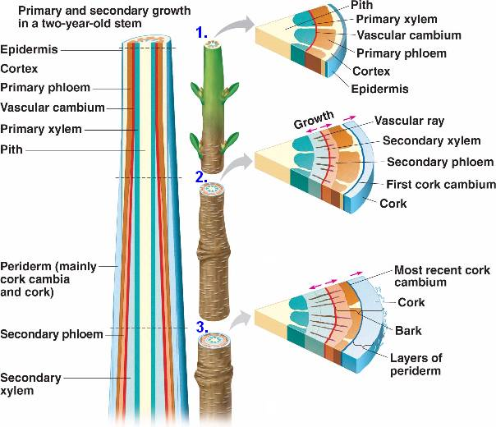

**Terminal bud scale scar**

**Terminal bud**

**scale scar**

**D (wood)**

**Primary and secondary growth in a plant stem**

**D**

**B**

**C**

**A**

**B**

**A**

**F**

**E**

**C**

**G**

**G**

**H**

**H**

**F**

**E**

www.nicerweb.com

The primary phloem (**C**) does not persist. It is functional for only a few years and then becomes crushed by further increase in the diameter of the stem. The functions of the crushed primary phloem are taken over by the younger (more recently produced) secondary phloem (**E**).

The production of secondary xylem and phloem causes the stem to increase in diameter. The epidermis (**F**) of the small stem is soon shed from the tree, and its function is taken over by a layer of cork cells (**G**) produced by another meristematic region, the **cork cambium** (**H**). The cork cambium forms in the cortex or secondary phloem (**E**) and produces cork cells. The cork cells become the outermost cells of the tree's trunk and branches (and woody roots, too). “Bark” describes **all** the tissues outside of the vascular cambium (**A**), principally the secondary phloem (**E**) as well as the cork (**G**).

**Differentiation --** We will examine how meristematic tissue produces cells that differentiate into different plant parts. Using an easy and reliable lab technique for tissue culture, you will clone a cauliflower plant using apical meristem tissue. The edible part of cauliflower is, in fact, all apical meristem tissue. We will use a small piece of the cauliflower apical meristem to grow new plant cells. While growing, you should see the cells develop into tissues such as stems and leaves.

Start your cauliflower plant culture tube and record the growth over the remainder of the semester.   
This project will help illustrate how meristematic tissue develops into different plant parts and 2) how conservationists and horticulturalists can propagate plants, including rare plants, without disturbing the donor plant. This cauliflower activity comes from SAPS (Science and Plants in Schools) tissue cloning and rare plant conservation activity. (<http://www.saps.org.uk/secondary/teaching-resources/706-cauliflower-cloning-tissue-culture-and-micropropagation>)

**A. WOODY STEMS – examining young tree cross-sections**

1. Examine cross sections of woody stems (young trees) *Quercus* (oak) and *Picea* (spruce)**.   
Draw a cross section of these tree branches and label: wood, annual rings, sapwood, heartwood, bark, vascular cambium, and rays. What differences do you see?  
Label** the youngest wood (xylem) in the cross section, and the oldest wood.  
**Label** the youngest and oldest secondary phloem.

**B. MICROSCOPE SLIDES OF WOODY STEMS — Angiosperm and gymnosperm stems**

1. Examine cross-section slide of a young stem of *Tilia americana* (basswood) and *Pinus strobus* (white pine).  
**Draw and label: pith, secondary xylem, vascular cambium, secondary phloem and cork.**

How many years of growth appear on each stem cross-section? ___________

## *Lab 7:* Flowers, Fruits and Seeds

**Purpose**

To examine structure and function of flowers, seeds, and fruits.

**Introduction**

There are two main characteristics that distinguish angiosperms (flowering plants) from gymnosperms (non-flowering, seed-forming plants): 1) seeds enclosed within a fruit and 2) double fertilization within the ovule. Although these two features are common to all angiosperms, a large array of flower types has evolved in response to diverse pollinating mechanisms.

After pollination and fertilization, changes occur in the ovule and ovary. Both of these structures enlarge during development, with the ovule forming the seed and the ovary forming the fruit that encloses the seed or seeds.

Flowers are made up of four whorls of organs; these organs are modified leaf structures.

1) **sepals** — PS outer covering, protects developing flower

2) **petals** — attracts pollinators

3) **stamens** — male parts of plant

4) one or more **carpels** — female parts of plant (note: the pistil = one or more carpels)

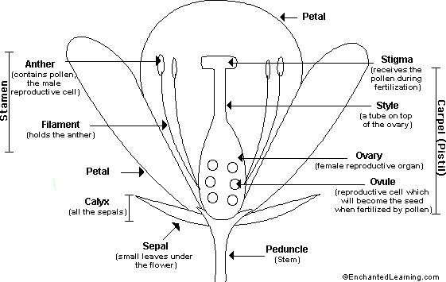

**Receptacle**

**Pistil** - comprised of   
 four female parts

**Stamen** - comprised of   
 two male parts

**Terms:** Define and learn the following terms. Use your manual or class text to help you.

**Seeds**

**Double fertilization**

**Ovule**

**Angiosperms**

**Pollination**

**Fertilization**

**Ovary**

**Petals**

**Stamens**

**Carpel(s)**

**Pistil**

**Fruit**

**Dehiscent**

**Pericarp**

**Receptacle**

**Procedures**

In lab today, you must complete the following four activities:   
A) dissect and draw the flower anatomy   
B) draw germinating pollen grains  
C) draw immature fruits

D) examine and key out six different fruits from those available in the classroom

## 

## FLOWERS

**A —**  Dissect a flower. **Draw, identify, and count the floral parts: sepals, petals, stamens, pistil (carpel) with stigma, style, ovary and ovules (estimate a count).**

**B —**  Germinate pollen from the anthers of *Impatiens* sp*.* flowers. Pollen tubes grow rapidly in water. Within an hour, the pollen tubes may be ten to fifteen times longer than the diameter of the pollen grain. The pollen tubes digest their way from the stigma, through the style, and eventually reach the ovule in the ovary.   
1) **Draw a germinating pollen grain at 20, 30 & 60 min after you have placed them in water.   
In what parts of plants does meiosis occur??**

**2) Obtain a prepared slide cross section (XS) of a pollen grain and draw the pollen grain.**

**C —**Obtain a prepared slide of the lily anther. **Find and draw a cell at Telophase I stage of Meiosis and a cell at Telophase II stage of Meiosis.**

Use arrows → to point out the main differences.

**Meiosis Telophase I Meiosis Telophase II**

## FRUITS and SEEDS

The variety of fruits seems nearly unlimited. There are accompanying terminology to describe these vast differences. This variety includes fruits that are dry and those that are fleshly, fruits that split open and those that remain closed, and fruits that form from one pistil and those that form from multiple pistils.

Fruits are often grouped by the following four major types:  
1. Simple fruits

2. Aggregate fruits

3. Multiple fruits

4. Accessory fruits

**1) Simple fruits** – formed from a single pistil

**Dry Indehiscent** – at maturity, these fruits DO NOT split open.

**Achene** – a dry, one-seeded seed that is free inside a hollow fruit.   
 Sunflower “seeds” actually are fruits called **achenes**, each one containing single seed.

**Grain** -- the dry seeds or fruit of a cereal grass (monocotylydons) generally with close fitting   
 pericarp. In corn and all other grains (wheat, rice, and oats), the fruit wall and the seed   
 coat are fused together. A corn “seed” also is a fruit, called a **caryopsis** or **grain**

**Nut** – the hard shell is the thick, woody pericarp that has the fruit and the nut inside. It does not   
 open when mature. Ex. Chestnuts, hazelnuts, acorns

**Dry Dehiscent** – at maturity, these dry fruits SPLIT open.

**Legume** –  long dry dehiscent fruit produced inside a pod that splits along two sides, seeds are   
 attached along one side.

**Capsule** – dry dehiscent fruit, composed of two or more carpels. Dry fruit opens at maturity.   
 Examples: poppy, lily, orchid, cotton.

**Schizocarp** -- a dry fruit that splits into two or more one-seeded segments formed from separate   
 carpels. Examples: maple seeds (paired samaras), dill.

**Fleshy** – at maturity, these fleshy fruits generally do not split open.

**Drupe** – simple fruit derived from a single carpel. The drupe usually has one (sometimes two)   
 seed(s) enclosed by a single, hard endocarp. Fleshy, soft, edible exocarp and mesocarp or   
 fibrous mesocarp often surrounding hard pit (or stone). Ex. peaches, plums, cherries,   
 olives, dates, coconuts.

**Berry** – having one- many seeds, without the inner stone or pit. The entire outer pericarp is   
 fleshy, although skin is sometimes tough. Ex. Tomato, grape, pomegranate.

**Pepo** – berry with a thick hard rind. Ex. Watermelon.

**Hesperidium** – berry with a leathery rind. Ex. Citrus

.

**2) Aggregate fruits** – formed from one flower, essentially a collection of drupes. Aggregate fruit is the fusion of several separate pistils. In raspberries and blackberries (**aggregate fruits**), fruits develop from a single flower but the flower contains many separate carpels. Each little sphere is a small drupe (a “drupelet”) derived from a single ovary and containing one seed.

**3) Multiple fruits** – formed from several flowers grouped together, by the fusion of several separate pistils, from different flowers. Figs (**multiple fruits**) form when a cluster of flowers (thus many carpels) are fertilized.

**4) Accessory fruits** – fruits formed from plant parts other than the ovary. ; the strawberry is actually a number of tiny achenes (miscalled seeds) outside a central pulpy pith that is the enlarged receptacle or base of the flower.

**Pome** – **Accessory fruit** – a fruit in which the seed in enclosed by outer fruit, formed from   
 perianth segments (petals and sepals). Pome fruit is formed by members of the rose   
 family (Rosaceae). Ex. apple, pear  
 **Aggregate**–**Accessory fruit** – a fruit in which the seed in enclosed by outer fruit, formed from  
 In strawberries the receptacle of the flower forms the red, edible portion and the “seeds”   
 are small achenes on this receptacle.

-----------------------------------------------------------------------------------------------------------------------------



**D — Draw and identify on an immature fruit: pistil (carpel) with stigma, style, ovary, and sepals**Beans are dry, dehiscent (= splitting open when mature) fruits termed legumes. Carefully remove the shell (fruit wall) of this fruit. Notice that it splits open readily and contains seeds, usually two. The papery, red skin found over the seeds of a peanut is called the seed coat. Notice the similarity of the immature bean fruit to the mature peanut fruit. Both of these are legumes.

**Answer the following questions:**

Split the bean open and record how many ovules are present in this fruit.

Are all of the ovules in this fruit maturing into seeds?

What changes occurred, as a flower became a fruit?

What part of the flower enlarged to form the fruit?

**E —** A tomato is a fleshy fruit in which all parts of the fruit wall are fleshy. This type of fruit is called a **berry**. If you examine a tomato cut in half lengthwise, you will see the outer fruit wall (exocarp) is called the “skin.” The rest of the tomato (mostly the mesocarp) is soft and watery and has high sugar content. Running down the center of the fruit are vascular bundles (xylem and phloem) to which are attached to the seeds.   
**What seed dispersal mechanisms are suggested by the tomato fruit's form?**

.

**Key to the Classification of Fruits**

1. Simple fruits, formed from a single ovary -------------------------------------------------------------------------------- 2

1. Compound fruits, formed from several ovaries--------------------------------------------------------------------------- 17

**simple fruits**

2. Dry fruits----------------------------------------------------------------------------------------------------------------------- 3

2. Fleshy fruits------------------------------------------------------------------------------------------------------------------- 12

3. Fruit dehiscent----------------------------------------------------------------------------------------------------------------- 4

3. Fruit indehiscent--------------------------------------------------------------------------------------------------------------- 7

4. Fruit derived from one carpel only----------------------------------------------------------------------------------------- 5

4. Fruit derived from one to several carpels---------------------------------------------------------------------------------- 6

5. Fruit splitting at maturity along one suture------------------------------------------------------------------------- **Follicle**

5. Fruit splitting at maturity along two sutures----------------------------------------------------------------------- **Legume**

6. Fruit formed of 2 carpels, separating at maturity, leaving a persistent partition upright between them---- **Silique**

6. Fruit formed of several carpels-------------------------------------------------------------------------------------- **Capsule**

7. Fruit several to many-seeded, breaking at maturity into several one-seeded segments---------------------- **Loment**

7. Fruit not as above, generally one-seeded---------------------------------------------------------------------------------- 8

8. Seed coat firmly united with pericarp at all points------------------------------------------------------------- **Caryopsis**

8. Seed coat not attached to pericarp at all points---------------------------------------------------------------------------- 9

9. Pericarp thin, with one or two wings------------------------------------------------------------------------------- **Samara**

9. Pericarp lacking wings------------------------------------------------------------------------------------------------------- 10

10. Fruit coat very hard------------------------------------------------------------------------------------------------------- **Nut**

10. Fruit coat not particularly hard-------------------------------------------------------------------------------------------- 11

11. Fruit composed of 2 carpels, separating at maturity into two 1-seeded halves or mericarps which are

indehiscent----------------------------------------------------------------------------------------------------- **Schizocarp**

11. Fruit coat thin, not separating; fruit small, 1-seeded------------------------------------------------------------ **Achene**

12. Fleshy part of fruit derived from ovary only---------------------------------------------------------------------------- 13

12. Fleshy part of fruit derived, at least in part, from the receptacle----------------------------------------------------- 15

13. Entire ovary becoming fleshy at maturity ------------------------------------------------------------------------------ 14

13. Outer part of ovary fleshy, inner part stony------------------------------------------------------------------------ **Drupe**

14. Fruit fleshy or juicy, composed of several (usually 10) carpels, each with 2 seeds; rind leathery-- **Hesperidium**

14. Fruit fleshy, of several carpels, each with one to several seeds; leathery rind lacking------------------------ **Berry**

15. Pistils several, separate, non-fleshy, enclosed by the fleshy or semi-fleshy receptacle------------------------- **Hip**

15. Ovary compound, carpels united----------------------------------------------------------------------------------------- 16

16. Ovary wall fleshy, berry-like, with hard rind------------------------------------------------------------------------ **Pepo**

16. Inner part of ovary wall papery or cartilaginous, outer part fleshy, surrounded by and united with a fleshy receptacle------------------------------------------------------------------------------------------------------------- **Pome**

**compound fruits**

17. Many simple fruits, usually achenes or drupes, derived from separate carpels of one flower,   
located on a single receptacle------------------------------------------------------------------------ **Aggregate Fruit**

17. Many simple fruits derived from the carpels of separate flowers---------------------------------------------------- 18

18. Flowers borne within an enlarged hollow, fleshy receptacle------------------------------------------------ **Syconium**

18. Flowers borne upon the surface of a more or less fleshy receptacle---------------------------------- **Multiple Fruit**

## *Lab 8:* Population Ecology Predator –prey interactions

This lab, Isle Royale, from: SimBio Virtual Labs™: EcoBeaker®*© 2010, SimBiotic Software for Teaching and Research, Inc. All Rights Reserved.*

**Introduction**

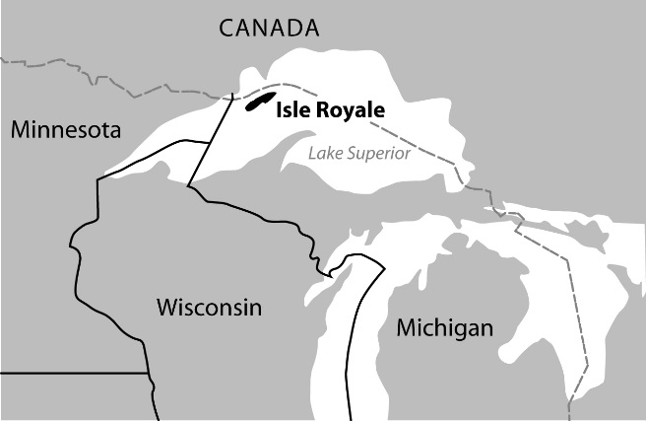The Wolves and Moose of Isle Royale

If you were to travel on Route 61 to the farthest reaches of Minnesota and stand on the shore of Lake Superior looking east, on a clear day you would see Isle Royale. This remote, forested island sits isolated and uninhabited 15 miles off of the northern shore of Lake Superior, just south of the border between Canada and the USA. If you had been standing in a similar spot by the lake in the early 1900s, you may have witnessed a small group of hardy, pioneering moose swimming from the mainland across open water, eventually landing on the island. These fortunate moose arrived to find a veritable paradise, devoid of predators and full of grass, shrubs, and trees to eat. Over the next 30 years, the moose population exploded, reaching several thousand individuals at its peak. The moose paradise didn’t last for long, however.

Lake Superior rarely freezes. In the 1940s, however, conditions were cold and calm enough for an ice bridge to form between the mainland and Isle Royale. A small pack of wolves found the bridge and made the long trek across it to the island. Once on Isle Royale, the hungry wolves found their own paradise — a huge population of moose. The moose had eaten most of the available plant food, and many of them were severely undernourished. These slow-moving, starving moose were easy prey for wolves.

The Isle Royale Natural Experiment

The study of moose and wolves on Isle Royale began in 1958 and is thought to be the longest-running study of its kind. The isolation of the island provides conditions for a unique natural experiment to study the predator-prey system. Isle Royale is large enough to support a wolf population, but small enough to allow scientists to keep track of all of the wolves and most of the moose on the island in any given year. Apart from occasionally eating beaver in the summer months, the wolves subsist entirely on a diet of moose. This relative lack of complicating factors on Isle Royale compared to the mainland has made the island a very useful study system for ecologists.

The EcoBeaker® Version of Isle Royale

During this lab, you will perform your own experiments to study population dynamics using a computer simulation based on a simplified version of the Isle Royale community. The underlying model includes five species: three plants (grasses, maple trees, and balsam fir trees), moose, and wolves. If you were actually watching a large patch of moose-free grass through time, you would observe it slowly transforming into forest. Likewise, the simulated plant community exhibits a simple succession from grasses to trees.

While the animal species in the Isle Royale simulation are also simplified compared with their real-world counterparts, their most relevant behaviors are included in the model. Moose prefer to eat grass and fir trees. Wolves eat moose, more easily catching the slower, weaker moose. Each individual animal of both species has a store of fat reserves that decreases as the individual moves around and reproduces, and increases when food is consumed. Both moose and wolves reproduce; however, for simplicity, the simulation ignores gender. Any individual with enough energy simply duplicates itself, passing on a fraction of its energy to its offspring. Death occurs when an individual’s energy level drops too low. Because weaker moose move at slower speeds, they take longer to find food and move away from predators, so their chance of survival is lower than for healthier moose. In the EcoBeaker simulation, wolves hunt alone, whereas in the real world, wolves are social animals that hunt in packs. These simplifications make the simulation tractable, while still retaining the basic qualitative nature of how these species interact.

Some Important Terms and Concepts

Population Ecology ―Population ecology is the study of changes in the size and composition of populations and the factors that cause those changes.

Population Growth ― Many different factors influence how a population grows. Mathematical models of population growth provide helpful frameworks for understanding the complexity involved, and also (if the models are accurate) for predicting how populations will change through time. The simplest model of population growth considers a situation in which limitations to the population’s growth do not exist (that is, all necessary resources for survival and reproduction are present in continual excess). Under these conditions, the larger a population becomes, the faster it will grow. If each successive generation has more offspring, the more individuals there will be to have even more offspring, and so on. This type of population growth is described with the exponential growth model.

The exponential growth model assumes that a population is increasing at its maximum per capita rate of growth (represented by ‘rmax’) also known as the “intrinsic rate of increase”.   
If population size is N and time is t, then: 

The notation ‘dN/dt’ represents the “instantaneous change” in population size with respect to time. In this context, “instantaneous change” simply means how fast the population is growing or shrinking at any particular instant in time. The equation indicates that at larger values of N (the population size), the rate at which the population size increases will be greater.

The following graph depicts an example of exponential population growth. Notice how the curve starts out gradually moving upwards and then becomes steeper over time. This graph illustrates that when the population size is small, it can only increase in size slowly, but as it grows, it can increase more quickly.

**Exponential Population Growth Curve**

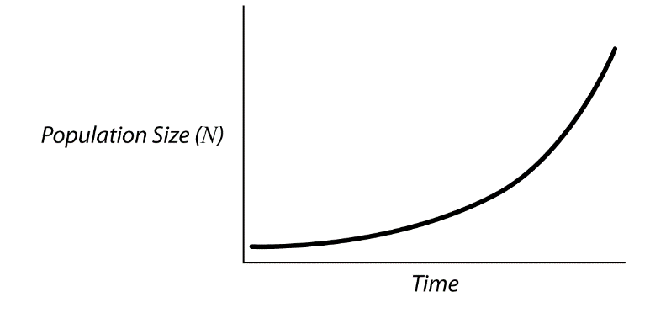Carrying Capacity

In the real world, conditions are generally not as favorable as those assumed for the exponential growth model. Population growth is normally limited by the availability of important resources such as food, nutrients, or space. A population’s carrying capacity (symbolized by ‘K’) is the maximum number of individuals of that species that the local environment can support at any particular time. When a population is small, such as during the early stages of colonization, it may grow exponentially (or nearly so) as described above. As resources start to run out, however, population growth typically slows down and eventually the population size levels off at the population’s carrying capacity.

To incorporate the influence of carrying capacity in projections of population growth rate, ecologists use the logistic growth model. In this model, the per capita growth rate (r) decreases as the population density increases. When the population is at its carrying capacity (i.e., when   
N = K ) the population will no longer grow. Again, using the ‘dN/dt’ notation, if the maximum per capita rate of growth is rmax, population size is N, time is t, and carrying capacity is K, then:



When the population size (N) is near the carrying capacity (K), K-N will be small and hence,   
(K-N)/K will also be small. The change in the population size through time (dN/dt) will therefore decrease and approach zero (meaning the population size stops changing) as N gets closer to K.

The following graph depicts an example of logistic growth. Notice how it initially looks like the exponential growth graph but then levels off as N (population size) approaches K (carrying capacity).

Logistic Population Growth

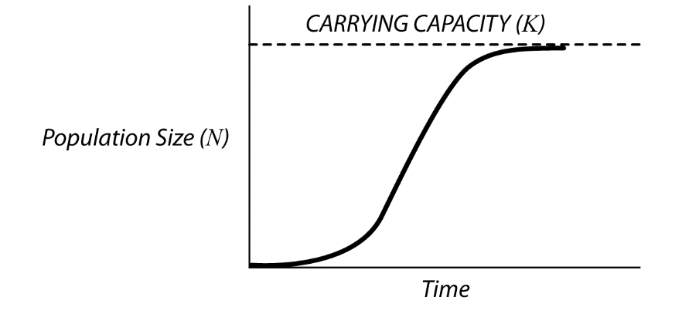While the logistic model is more realistic than the exponential growth model for most populations, many other factors can also influence how populations change in size through time. For example, the growth curve for a recently-introduced species might temporarily overshoot the population’s carrying capacity. This would happen if the abundance of resources encountered by the colonizing individuals stimulated a high rate of reproduction, but the pressures of limited resources were soon felt (i.e., individuals might not start dying off until after a period of rapid reproduction has already taken place).

Graphs based on real population data are never such smooth, neat curves as the ones above. Random events almost always cause population sizes and carrying capacities to fluctuate through time. Interactions with other species, such as predators, prey, or competitors, also cause the size of populations to change erratically. To estimate carrying capacity in situations such as these, one generally calculates the median value around which the population size is fluctuating.

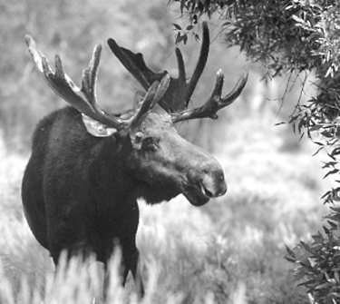**Exercise 1: The Moose Arrive**

In this first exercise, you will study the moose on Isle Royale before the arrival of wolves. The lab simulates the arrival of the group of moose that swam to the island and rapidly reproduced to form a large population.

[ 5.1 ] What is the approximate size of the stable moose population? ________

[ 5.2 ] What was the (approximate) maximum size the moose population attained? ________

[ 6 ] Using the horizontal and vertical axes below, roughly sketch the population size graph showing the simulated moose population changing over time. Label one axis “POPULATION SIZE (N)” and the other one “TIME (years)”. You do not need to worry about exact numerical values; just try to capture the shape of the line.

[ 6.1 ] Examine your graph and determine the part that corresponds to the moose population growing exponentially. Draw a circle around that part of the moose population curve you drew above.

[ 6.2 ] The moose population grew fastest when it was:

Smallest Medium-sized Largest (Circle one)

[ 6.3 ] What is the approximate carrying capacity of moose? Draw an arrow on your graph that indicates where the carrying capacity is (label it “K”) and then write your answer in the space below:

[ 7 ] The following logistic growth equation should look familiar. (If not, revisit the Introduction.)



[ 7.1 ] What does “dN/dt” mean, in words?

[ 7.2 ] Think about what happens to dN/dt in the equation above when the population size (N) approaches the carrying capacity (K)? Think about the case when the two numbers are the same (N = K). Rewrite the right-hand side of the equation above, substituting K for N. Write this new version of the equation below:

dN/dt = _________________ when N=K

[ 7.3 ] Look at the equation you just wrote and figure out what happens to the right-hand side of the equation. Then complete the following sentences by circling the correct choices.

According to the logistic growth equation, when a growing population reaches its carrying capacity (N = K),

dN/dt = 0 / 1 / K / N / rmax (Circle one),

and the population will: grow more rapidly / stop growing / shrink (Circle one)

[ 8 ] Look at the graph in the introduction that depicts an example of logistic growth and compare that to your moose population growth graph.

[ 8.1 ] Sketch both curves in the spaces provided below. (Don’t worry about the exact numbers; just show the shapes of the curves. Be sure to label the axes!)

[ 8.2 ] How do the shapes of the curves differ? Describe the differences in terms of population sizes and carrying capacities.

[ 8.3 ] Provide a biological explanation for why the moose population overshoots its carrying capacity when moose first colonize Isle Royale. (HINT: consulting the Introduction might help.)

[ 8.4 ] At year 50 or later, with the moose population at its carrying capacity, what would happen if an extra 200 moose suddenly arrived on Isle Royale? How would this change the population graph over the next 20 to 30 years? In the space provided, draw a rough sketch of what you think the graph would look like under these conditions. Be sure to label the axes.

[ 10 ] Click GO to continue running the simulation for 20 to 30 more years and watch what happens to the moose population. Click STOP to pause the simulation. Then answer the following questions:

[ 10.1 ] Did you predict correctly in question 8.3? ________

[ 10.2 ] What is the carrying capacity of moose on Isle Royale after adding 200-300 new moose? ______________

**Exercise 2: The Wolves Arrive**

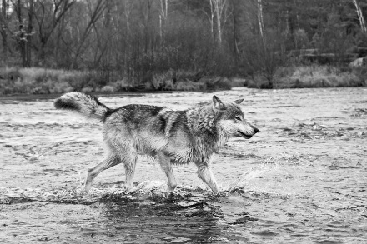One especially cold and harsh winter in the late 1940s, Lake Superior froze between the mainland and Isle Royale. A small pack of wolves traveled across the ice from Canada and reached the island. In this second exercise, you will investigate how the presence of predators affects the moose population through time.

[ 2 ] Click STEP 50 to advance the simulation 50 years. You will see moose arrive and run around the island eating plants as before. Next, you will add some wolves to the island, but first answer the following question:

[ 2.1 ] How do you predict the moose population graph will change with predatory wolves in the system? Will the moose population grow or shrink?

[ 3 ] Activate the ADD WOLF button in the Tools panel by clicking it. Add 20-40 wolves to Isle Royale by drawing small rectangles on the island (they will fill with wolves) until you have succeeded in helping the wolf population to get established.

[ 4 ] Run the simulation for about 200 years (you can click STEP 50 four or five times). Observe how the moose and wolves interact, and how the population graph changes through time. (To better observe the system you can try changing the simulation speed or zoom level.)

[ 4.1 ] In the space below, copy the moose-wolf population graph starting with the time when wolves were established. Make sure you label the axes.

[ 4.2 ] Did the introduction of wolves cause the moose population size to decrease or increase? If so, how much smaller or larger (on average) is the moose population when wolves are present?

[ 4.3 ] You should have noticed that the populations of moose and wolves go through cycles. (If not, run the simulation for another 100 years.) Describe the pattern and provide a biological explanation for what you observe. Does the moose or the wolf population climb first in each cycle? Which population drops first in each cycle?

[ 6.1 ] All else being equal, which do you think would be healthier (on average), moose on an island with wolves or moose on an island without wolves? Explain your reasoning.

[ 10.1 ] Record the values on the right-hand side of the table.

|  |  |  |  |
| --- | --- | --- | --- |
| Without Wolves | | With Wolves | |
| Moose | Fat Stores | Moose | Fat Stores |
| 1 |  | 1 |  |
| 2 |  | 2 |  |
| 3 |  | 3 |  |
| 4 |  | 4 |  |
| 5 |  | 5 |  |
| 6 |  | 6 |  |
| 7 |  | 7 |  |
| 8 |  | 8 |  |
| 9 |  | 9 |  |
| 10 |  | 10 |  |
| MEAN = |  | MEAN = |  |

[ 10.2 ] Calculate and record the mean fat stores of adult moose with wolves absent and present in the table above. (You can open your computer’s calculator by clicking the CALCULATOR button near the lower right corner of your screen.)   
Provide a biological explanation for any differences.

*© 2010, SimBiotic Software for Teaching and Research, Inc. All Rights Reserved.*

**Exercise 3: Changes in the Weather**

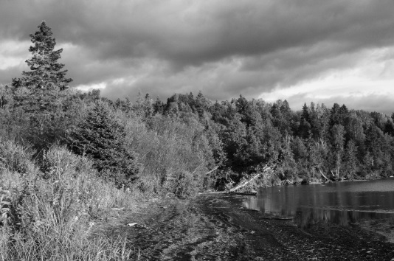You have probably heard that scientists are concerned about climate change and the effects of global warming due to increasing atmospheric greenhouse gases. Recent evidence suggests that temperatures around the world are rising. In particular, the average yearly temperature in northern temperate regions is expected to increase significantly. This change will lead to longer, warmer spring and summer seasons in places like Isle Royale. The duration of the growing season for plants will therefore be extended, resulting in more plant food for moose living on the island.

How would a longer growing season affect the moose and wolf populations on Isle Royale? Would they be relatively unaffected? Would the number of moose and wolves both increase indefinitely with higher and higher temperatures, and longer and longer growing seasons?

One way ecologists make predictions about the impacts of global warming is by testing different scenarios using computer models similar to the one you’ve been using in this lab. Even though simulation models are simplifications of the real world, they can be very useful for investigating how things might change in the future. In this exercise, you will use the Isle Royale simulation to investigate how changes in average yearly temperature due to global warming may affect the plant-moose-wolf system on the island.

[ 4.1 ] Estimate the average and maximum sizes for moose and wolf populations after the wolves have become established. Record these values below:

Maximum moose population size: _________________

Maximum wolf population size: _________________

Average moose population size: _________________

Average wolf population size: _________________

[ 5.1 ] Predict how moose and wolf population trends will differ with the **Short growing season** compared to the Normal scenario. Will average population sizes be smaller or larger? Why?

[ 7 ] Estimate the maximum and average sizes for moose and wolf populations after several cycles with a ‘Short’ growing season.

[ 7.1 ] Record these values below:

Maximum moose population size: _________________

Maximum wolf population size: _________________

Average moose population size: _________________

Average wolf population size: _________________

[ 7.2 ] How do these numbers compare to those you observed with the Normal growing season (Step 4 above)?

[ 8 ] In the short growing season, the plant growth is half of what it was before.

[ 8.1 ] Based on your measurements, how much do you think the moose carrying capacity changed, and why?

[ 9 ] Now it’s time to consider the warming scenario.

[ 9.1 ] How do you predict that moose and wolf population trends will differ with a Long growing season, and why?

[ 12 ] Click stop and estimate the maximum and average size for moose and wolf populations under the **Long growing season** scenario.

[ 12.1 ] Record these values below:

Maximum moose population size: _________________

Maximum wolf population size: _________________

Average moose population size: _________________

Average wolf population size: _________________

[ 12.2 ] If you watched for a while, you probably saw some species go extinct. If you didn’t observe extinctions, you can continue to run the simulation until you see this dramatic phenomenon. Explain why you think extinction is more likely in this scenario than the other two (this is known as the “paradox of enrichment”).

[ 12.3 ] Looking at your results from running the simulation under the normal climate conditions and the two alternative scenarios, were your predictions correct? Provide biological explanations for the trends and differences that you observed. Pay particular attention to how the population cycles changed (e.g., increased, decreased, became less stable) as the rate of plant growth changed.

[ 12.4 ] [Optional] If you have already talked about global warming and climate change in class, provide another example of how increased yearly temperature can affect an animal or plant population. In particular, think about pests, invasive species, disease, or species of agricultural importance.

## Predator – prey interactions – extension exercise

This lab, Isle Royale, from: SimBio Virtual Labs™: EcoBeaker®*© 2010, SimBiotic Software for Teaching and Research, Inc. All Rights Reserved.*

**What’s the Difference?**

In Part 1, Exercise 2 you conducted an experiment comparing health of moose with wolves absent to health of moose with wolves present. You probably observed at least a small difference between the samples, but does that really indicate that moose have greater fat stores when wolves are present? The difference could be related to wolves, but it could also have arisen simply by chance. You might have accidentally selected very healthy moose one time and unhealthy moose the other. How can you know whether the difference in means between two samples is real?

The short answer is that you can’t. But you can make a good guess using statistics. In fact, “inferential statistics” were invented to allow us to better uncover the truth and answer these sorts of questions. In this section, you will perform a simple statistical test, called a t-test, to decide whether or not the wolves’ presence had a significant effect on moose fat stores. If we were to be very thorough and formal in our t-test lesson, we would include a lengthy discussion of such concepts as random variables, sampling distributions, standard errors, and alpha levels. These are important, but to keep this short, we will just focus on the core ideas underlying the t-test.

You start with a question: Is the mean moose fat stores different when wolves are present versus absent? The **null hypothesis** is a negative answer: there is no real difference. Under the null hypothesis, the difference in your samples arises from chance. The **alternative hypothesis** is that there *is* an effect of wolves on moose fat stores. In order to know which hypothesis your samples support, we examine the difference in means *relative to the variability* you observed.

[ 1 ] Look back at Exercise 2 where you measured the fat stores of adult moose with wolves absent and present, and record those values here. Note that the subscript ‘*p*’ represents samples with wolves present, while ‘*a*’ represents those with wolves absent.

[ 1.1 ] Mean fat stores of adult moose, wolves present (): _________

[ 1.2 ] Mean fat stores of adult moose, wolves absent (): __________

[ 1.3 ] Calculate the difference in mean fat stores (): ___________

[ 2 ] Look at the following three hypothetical graphs. Each graph shows two distributions of moose fat stores, one with wolves present (lighter gray line) and one with wolves absent (darker line). Note that in each graph, mean moose fat stores are represented by dashed vertical lines, andthe ***difference in means is the same for all three***. However, the **variation** in fat stores is smaller in the distributions on the left, and larger in those on the right.

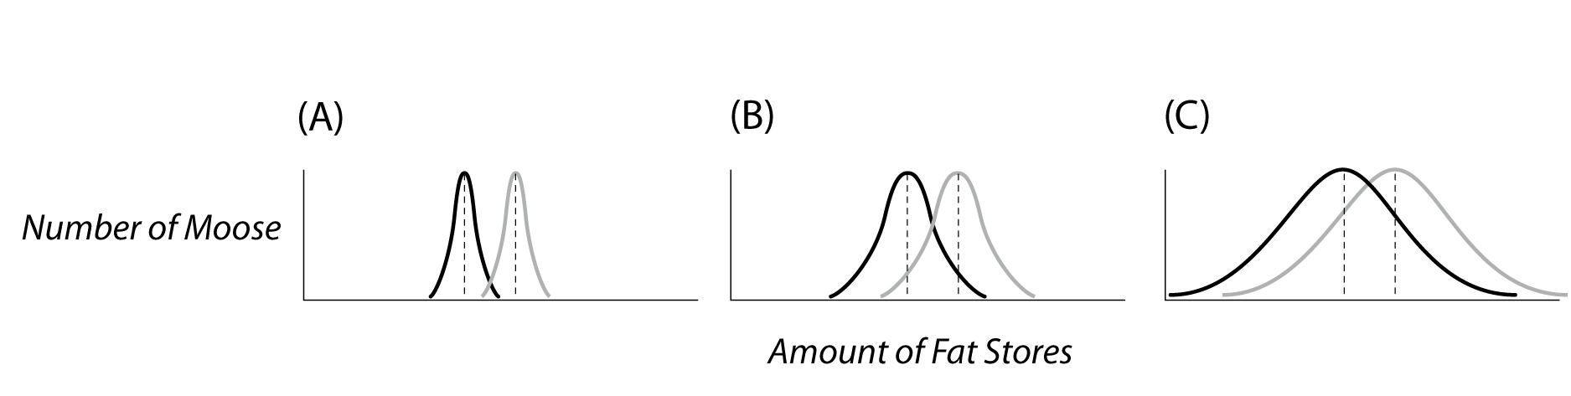

[ 2.1 ] Which of the above graphs (A, B, or C) would make the most convincing argument that the difference in fat stores is real, and not just due to chance?

[ 2.2 ] Explain your choice:

If there is a lot of variability in the data sets you are comparing, you will more likely see a difference in their means just by chance, supporting the null hypothesis. Only if the difference in means is large compared to the amount of variability in the data do you suppose that the difference might be real. A statistic called t formalizes this intuition –in fact, *t* is calculated as a ratio of ‘difference in means’ to ‘amount of variability’. Here is its formula (with the ‘p’ and ‘a’ subscripts referring to moose energy with wolves **p**resent vs. **a**bsent):



In the formula above, the mean values of the two samples is given by and . The variability of values within the sampled data sets is incorporated into the denominator, where ‘*SE’* stands for the ‘standard error of the sample-mean difference’ (a fancy-sounding phrase for a simple concept: ***variability***). Calculating this value is straightforward but requires a few steps if you are doing it ‘by hand’; the formula is:



Here, varp and vara are the variances for each sample, a measure of the amount of variability in the values. Finally, np and na are the number of samples in each data set. If you have never calculated variance before, don’t fret – this exercise will walk you through the calculation. Combining the two above equations yields the following formula for t:



[ 3 ] Examine the formula for t.

[ 3.1 ] Draw a square around the part of the formula for t that compares the means of the two data sets.

[ 3.2 ] Draw a circle around the part of the formula for t that describes the amount of variability in the data.

[ 3.3 ] If the means are close together, and the variability is high (so that the difference in means could more easily have arisen by chance), will the value of t be low or high?

[ 4 ] You probably noticed a difference in the health of moose when wolves were present versus when they were absent. To find out whether this difference is large enough to distinguish it from the null hypothesis, you have to calculate the *t* statistic for your moose fat stores data. Start by calculating the variance in each data set as follows.

[ 4.1 ] Go back to Section 2 and look at your table of adult moose fat stores. Copy the values from that table into the table below, in the column labeled ‘Fat Store’ (do this for both samples — with and without wolves).

[ 4.2 ] Focus first on your samples WITHOUT WOLVES. For each fat store value in that sample, subtract the mean fat store with wolves absent (from step [1.2] above), and enter this ‘difference from the mean’ in the column labeled . Remember you can click the CALCULATOR button near the lower right corner to open your computer’s calculator.

[ 4.3 ] Square each ‘difference from the mean’ and enter the squared value in the column labeled .

[ 4.4 ] Sum the squared differences. Enter the ‘sum of squares’ at the bottom of the table.

|  |  |  |  |  |  |  |  |
| --- | --- | --- | --- | --- | --- | --- | --- |
| WITHOUT WOLVES | | | | WITH WOLVES | | | |
| Moose | Fat Store |  |  | Moose | Fat Store |  |  |
| 1 |  |  |  | 1 |  |  |  |
| 2 |  |  |  | 2 |  |  |  |
| 3 |  |  |  | 3 |  |  |  |
| 4 |  |  |  | 4 |  |  |  |
| 5 |  |  |  | 5 |  |  |  |
| 6 |  |  |  | 6 |  |  |  |
| 7 |  |  |  | 7 |  |  |  |
| 8 |  |  |  | 8 |  |  |  |
| 9 |  |  |  | 9 |  |  |  |
| 10 |  |  |  | 10 |  |  |  |
| Sum of squared differences: | | |  | Sum of squared differences: | | |  |

[ 4.5 ] Divide the sum of squares by the ‘sample size’ (), that is, the number of moose whose fat stores you sampled (note that ‘sample size’ is different than ‘population size’). The result is the measure of variance you will use in the t-test:

vara = (sum squared differences)a /  = __________

[ 5 ] Repeat the above steps [4.2] through [4.5].

[ 5.1 ] Now calculate the variance for moose fat stores WITH WOLVES present. Remember this time to use the mean fat store with wolves present (from step [1.1] above).

varp = (sum squared differences)p /  = __________

[ 6 ] Now that you have calculated variances, you can calculate an overall measure of variability in your samples. (And yes, you will divide by the sample sizes again!)

[ 6.1 ] Plug your calculated variances into the equation below.

 = __________

[ 7 ] And now that you have calculated the standard error, you can calculate the value t of the t-test.

[ 7.1 ] What is the value t of the t-test, given the difference in means and the standard error of the sample-mean difference you calculated above?

 = _____________

The higher the value of *t*, the more confident you can be that the difference did not result from chance. But how confident are you? A common protocol is to call something ‘significant’ if the probability is less than 0.05 that the difference is due to chance alone. This probability is dubbed the ‘p-value’. Given the value of *t*, and something called the “degrees of freedom” in your data, you can determine the p-value (the probability of the difference occurring by chance) using a statistical table, or, better yet, using SimBio Virtual Lab’s handy-dandy t-test p-value calculator.

[ 8 ] The number of degrees of freedom in your t-test is equal to the total number of samples (20 in this case) minus 2. That is, ‘degrees of freedom’.

[ 8.1 ] How many degrees of freedom do your moose fat stores data have? __________.

[ 9 ] Launch the t-test p-value calculator by clicking the ‘t-test’ button on the Tools panel (very bottom right of your screen).

[ 9.1 ] In the dialog that appears, type in your t value and the degrees of freedom, and press the Calculate button. What is the probability of the null hypothesis being correct (i.e. that the difference was due to chance alone)?

[ 9.2 ] What can you say about moose fat stores with wolves absent vs. present, after performing the t-test?

**Key Publications**

A few researchers have studied the population dynamics of wolves and moose on Isle Royale for a very long time, resulting in an exceptional continuity in research approach and data collection. The research program is currently directed out of Michigan Tech by John Vucetich and Rolf Peterson, both of whom have published extensively on moose-wolf population dynamics. Below are a few references regarding moose and wolves on Isle Royale, the contribution of Isle Royale studies to broader ecological issues, and the scientific and conservation challenges involved.

Peterson, R.O., & Page, R.E.. 1988. The Rise and Fall of Isle Royale wolves, 1975-1986. Journal of Mammology, 69: 89-99.

Peterson, R.O. 1995. The Wolves of Isle Royale: A Broken Balance. Willow Creek Press, Minocqua, WI.

Vucetich, J.A., R.O. Peterson, & C.L. Schaefer. 2002. The Effect of Prey and Predator Densities on Wolf Predation. Ecology, 83(11): 3003-3013.

Vucetich, J.A., & R.O. Peterson. 2004. Long-Term Population And Predation Dynamics Of Wolves On Isle Royale. In: D. Macdonald & C. Sillero-Zubiri (eds.), Biology and Conservation of Wild Canids, Oxford University Press, pp. 281-292.

*© 2010, SimBiotic Software for Teaching and Research, Inc. All Rights Reserved.*

**Annual Reports Available @ http://www.wolfmoose.mtu.edu/**

*LAB 9***: Field sampling: Measuring diversity in a natural habitat   
Assessing plant diversity in the wild**

**Objectives**

1. Students will learn to sample plants in different field environments.
2. Students will use a taxonomic key to identify plants in field.
3. Students will compare and contrast environments.
4. Students will assess **species richness** and **species evenness** and estimate **species diversity** in the two environments.

**Field sampling**

***Why do we need to sample?*** When we want to learn about specific plants and animals, a good place to begin are to determine if the species under study is present, how many are present in a given area (density) and how that density compares to other species in the same area (evenness). A complete count of all the individuals in a plot (a census) would answer this question. However, it is usually impossible count every individual present unless those individuals are quite large. Even then, counting every individual poses real problems. Instead, scientists usually select representative sample sites in the area they need to survey, and follow rules to obtain an unbiased samples, samples truly representative of the area.

***How to choose a site?*** Researcher must be careful not to bias their samples. If determining the density and evenness of White Pine trees in North Woods, a scientist might be tempted to look in areas believed to have the most white pines. However, this might not give accurate estimates of white pines in relation to different trees.

When sampling, one must ensure that the sample is representative of the local population, without biasing the sample. Scientists use randomized sampling techniques to ensure that the chances of any individual being sampled is the same as any other individual. We will use a random number table to determine sampling sites in our sites.

***How do we sample?*** There are many commonly used standard sampling methods. Some common methods include quadrats and transect lines.

Quadrats are a sampling unit, often a circle or a square, of a known area. Common square quadrats sizes are 1/4m square or 1m square. The size of the quadrat will depend on the size of the organism being sampled. (A 1m2 quadrat might be useful for grass species in a field, but too large for assessing leaf mite eggs found per blade of grass in an area.)

Transect lines are long, measured tape lines, used to assess over large areas and to detect uncommon species. Common transect lines are 10, 30, and 100m. Again, the size of the transect line used depends on the size of the species sampled. Transect lines are especially good if sampling over a gradient (e.g., from a pond to dry forest, from lower to upper intertidal regions) or for sampling different zones of a gradient (e.g. samples near the pond vs samples in the dry forest, or samples in lower intertidal vs samples in upper intertidal.)

***How will we sample plant diversity in the field?***

We will collect samples from four environments: 1) high-sun, mowed field, 2) high-sun, wild field, 3) shady, mowed field, and 4) shady, wild forest/field. From these samples, we will determine A) what plant species groups live in each environment, B) how many of each live in each environment, and C) how those population numbers compare between species. With this data, we can compare species diversity in the four environments. We can also make hypotheses about the species found in the environments.

For each sample area, working in groups of 2-3 students, you will assess the plant species groups in three 1-meter long transects. The 1-m long sample transects will run perpendicular to the edge of the community and located randomly. You will be given random numbers telling you where to sample each area. Place the end of your meterstick approximately 25cm from the transect line corresponding to your random numbers. You will record any/all plant species group(s) at 10cm intervals along your meter stick.

Transect Line (meter tape)

Community Boundary

Each of the one meter long transect lines will provide an independent estimate of the cover of individual species and all of the species together.

For each transect line, record the distance each species’ canopy intersects the transect line (one selected side of the meterstick). The % cover of any species along that transect line is simply the total distance intersected along that line divided by the distance of the transect line times 100. For example, suppose the intersections of the following species on one transect line were recorded (in cm):

**Plant species found at 5cm intervals on meter-stick**

***Wide blade grass (crabgrass)*** 10, 15, 30, 40, 90, 95, 100

***Narrow blade grass*** 5, 20, 25, 30, 35, 50  
 ***Purslane*** 20, 45, 50, 55, 60, 65, 70, 75, 80, 85, 90

***Clover*** 25

**n** = the number of organisms of a single species

**n = number of times that species was counted**

***Wide blade grass (crabgrass)*** 7

***Narrow blade grass*** 6

***Purslane***  11

***Clover***  1

Because the total transect length was 100 cm and we sampled every 5cm (20samples total), % cover is calculated as:

**% Cover**

***Wide blade grass (crabgrass)*** ( 7 / 20) * 100 = 35%

***Narrow blade grass*** ( 6 / 20) * 100 = 30%

***Purslane*** (11 / 20) * 100 = 55%

***Clover*** ( 1 / 20) * 100 = 5%

Total Community Cover = 125%

Note that with overlapping canopies (as is common in real plant communities), total %cover for a community could exceed 100%.

***How do we identify the plant species?*** In the lab, you will have access to a taxonomic picture key. It should help you identify the plants into major groups. Please remember, this week your TA does not have “the right answer” to identifying all the organisms. Use the picture keys to identify, placing plants in the group it seems most similar to. Because of limited time and your limited expertise in the field of plant taxonomy, all the similar looking members of a group we will call a single species. Then we will use our “species numbers” for our data analysis.

***What do we do with our counts of the plant species groups?*** Using the numbers of similar individuals, we will count the plants to determine three quantifiable parameters that are generally used to assess the species diversity. **Species evenness** is the relative abundance of each species per unit area. **Species richness** is the number of different species per unit area. We will use these two counts to make estimates about species diversity. **Species diversity** is calculated from species richness (the number of different species per unit area) divided by species evenness (the number of each species per unit area).

***What do these terms really mean?*** The following example (from <http://www.countrysideinfo.co.uk>) illustrates the meaning of these terms. Biological diversity can be quantified in different ways but the main factors that influence diversity are richness and evenness. **Richness** is easy, the more species present in a sample, the 'richer' the sample. Species richness gives as much weight to those species represented by very few individuals as to those which have many individuals in the sample. Thus, in a field, one daisy has as much influence on the richness of an area as 1000 buttercups. **Evenness** is a measure of the *relative* abundance of the different species in the sample. So a sample has more evenness if all the species that are in the sample occur in the same number. In the example below, sample 1 is more even, sample 2 is less even. **Diversity** describes a combination of richness and evenness. See the following example from www.countrysideinfo.co.uk.

Example**.** Say we sampled two different fields for wildflowers. The sample from the first field consists of 300 daisies, 335 dandelions and 365 buttercups. The sample from the second field comprises 20 daisies, 49 dandelions and 931 buttercups (see the table below). Both samples have the same richness (3 species) and the same total number of individuals (1000). However, the first sample has more evenness than the second. This is because the total number of individuals in the sample is quite evenly distributed between the three species. In the second sample, most of the individuals are buttercups, with only a few daisies and dandelions present. Sample 2 is therefore considered to be less diverse than sample 1.

|  |  |  |
| --- | --- | --- |
|  | **Numbers of individuals** | |
| **Flower Species** | **Sample 1** | **Sample 2** |
| Daisy | 300 | 20 |
| Dandelion | 335 | 49 |
| Buttercup | 365 | 931 |
| **Total** | **1000** | **1000** |

*A community dominated by one or two species is considered to be less diverse than one in which several different species have a similar abundance.*

As species richness and species evenness increase, then species diversity increases. There are formulas designed to measure of diversity which accounts for both richness and evenness. **The Simpson’s Diversity Indices are used by many scientists to compare species diversity.** We will use the formula: **D =** Σ (**n(n–1))  
 N(N–1)**  
where: **n** = the number of organisms of a single species and   
 **N** = the total number of organisms of all species in that sample.We will then subtract D from 1 to get: **Simpson's Index of Diversity** **= 1 – D**

The Simpson’s Index of Diversity is a value that ranges between 0 and 1; the greater the value, the greater the sample diversity. In this case, the index represents the probability that two individuals randomly selected from a sample will belong to different species.

**Procedure**

Working in groups of 2-3 people, every group will sample two sunny locations and two shady locations, comparing mowed grass to non-mowed field/forest. The TA will place the 30m transect line along the border of the sites to be assessed.

1. The TA will give each group three random numbers. These are the 3 places along the transect line the group will sample.
2. Place the meter-stick ~25cm from the transect line, perpendicular to the line.
3. Using the picture key, identify and record all the plant species that are adjacent to the meter-stick. Record the distance the plant occupies. This may take 5 – 10min / meter sample. Some places there may be multiple plant species directly adjacent to the meter-stick. Other places there may be no plants. Final numbers will not necessarily equal 100% coverage.
4. Repeat for three one meter samples in each location.
5. Back in the lab, translate your values into % coverage values.
6. Count the number of different “species” you counted. This is your **species richness** value.
7. Write the Linear cm coverage values for each plant species in your samples in Col. B.
8. In Col. C, subtract 1 from value in Col. B.
9. In Col. D, multiply Col. B * Col. C.
10. Determine N: Add up all the values in Col.B and write the value in cell B18.   
     *(Do not include the palm tree example (4) in cell B2.)*
11. Determine (N—1): Subtract 1 from N, and write into cell B19.
12. Determine N (N-1): Multiply N {cell B18} times N – 1 {cell B19}.
13. The Greek symbol sigma, “∑,” in mathematical terms means to find the “sum of the following terms.” So in cell D18, you simply need to add up all the n(n-1) values; add all of col.D.

Remember: n = # plants of a single species

N = total # plants (of all species)**Table 1. Raw Data and Calculations of Species Counts from Field Samples**

|  |  |  |  |  |  |  |
| --- | --- | --- | --- | --- | --- | --- |
|  | **A** | **B** | **C** | | **D** | |
| **1** | **Species  (we will use Categories)** | **Number counted (n)** | **(n-1)** | | **n(n-1)** | |
| **2** | *Example: cactus* | *4* | *3* | | *12* | |
| **3** |  |  |  | |  | |
| **4** | Fine leaf grass |  |  | |  | |
| **5** | Wide leaf grass (crabgrass) |  |  | |  | |
| **6** | Moss |  |  | |  | |
| **7** | Fern |  |  | |  | |
| **8** | Chickweed |  |  | |  | |
| **9** | Purslane |  |  | |  | |
| **10** | Violets |  |  | |  | |
| **11** | Clover |  |  | |  | |
| **12** | Dandelion |  |  | |  | |
| **13** | Morning glory |  |  | |  | |
| **14** | Buttonweed |  |  | |  | |
| **15** | Short (<15cm) broadleaf |  |  | |  | |
| **16** | Tall (>15cm) broadleaf |  |  | |  | |
| **17** |  |  |  | |  | |
| **18** | **Total (N)** 🡪 |  | **∑ (n(n–1))** 🡪 | |  | |
| **19** | **(N – 1)** |  |  | |  | |
| **20** | **N(N – 1)** |  |  | |  | |
| **21** | **Simpson’s Index** | **D=∑(n(n–1))  N(N – 1)** | | **D18 ­=  B20** | |  |
| **22** | **Simpson’s Index of Diversity** | **1–D** | | **1–C21=** | |  |

**Remember: n = # organisms of a single species**

**N = total # organisms (of all species)**

1. Now substitute into the formula:   
   Simpson’s Index: **D = ∑ (n(n–1))**  which would be **D = cell D18   
    N(N – 1) cell B20**
2. Lastly solve for **Simpson’s Index of Diversity**, which is **1-D.**   
    Take your value of D (from step 17) and subtract it from 1.   
    Now, your Simpson’s Diversity Index is between 0 and 1.

***What does the Simpson’s Diversity Index value mean??***   
“Simpson’s Diversity Index” (DI) is a standardized, mathematical way of describing the variety of plant species groups in your samples. We calculated the D.I.to mathematically compare different, sampled areas.   
The Simpson’s D.I. value is always between 0 and 1.   
  
**The closer your D.I. value is to ONE, the greater your sample diversity.**

**Table 2. Class Data – Reporting Simpson’s Index of Diversity Values**

|  |  |  |  |  |  |  |  |  |
| --- | --- | --- | --- | --- | --- | --- | --- | --- |
|  | **Mowed-grass Samples** | | | | **Wild-field/forest Samples** | | | |
| **Class Groups** | **1** | **2** | **3** | **4** | **1** | **2** | **3** | **4** |
| Species Richness |  |  |  |  |  |  |  |  |
| Total # plant species counted |  |  |  |  |  |  |  |  |
| Simpson’s Diversity Index |  |  |  |  |  |  |  |  |
| AVG.  Simpson’s Diversity Index | Mowed grass average: ________ | | | | Wild area average: ________ | | | |

***What does the Simpson’s Diversity Index mean??***   
Your “Simpson’s Index of Diversity” value is between 0 and 1.   
**The closer your value is to ONE, the greater your sample diversity.**

**Questions to think about**

1. List the area that had the greatest species diversity as reported using the Simpson’s Index of Diversity? Why do you think that area had the highest diversity?
2. Did you expect that area to have the greatest diversity? Why or why not?
3. List the most abundant species in the data set. Why do you think it was most abundant?
4. (Just for fun…) What was your favorite organisms you collected today and why?   
    Which were your least favorite and why?
5. (Thought question…) Do you think that the Simpson’s Index of Diversity gives a good indication of the species present or not? WHY??

For more information on species diversity, try the following sites that were used to make this lab: <http://evolution.berkeley.edu>, and http://www.countrysideinfo.co.uk.

## Lab 10: CAMPUS PLANT WALK

Student report & presentations on local flora and greenhouse plants

**Objective:**

1) Familiarity with the some of the tree and plant species represented on campus

2) To give students opportunity to demonstrate their increased knowledge of the world of plants.

**Introduction**

We will end the semester with a walk around URI campus to learn about selected trees and plants in one of the URI greenhouses. Every laboratory section will be given a list of selected trees and plants found on campus and in one of the campus greenhouses. From these, students will be assigned a plant for a presentation and report. The TAs will provide a rubric to explain this assignment in detail.

During the walk around campus and into the greenhouse, each student will give a **1-2 minute** presentation on their chosen tree or plant. The presentations will be given orally (yes, you can use one note card). Students will tell the class the common name, the scientific name, whether the plant is indigenous to RI, and give us **three facts** about their plant. Students should practice their presentation to ensure that it fits within the 1-2 min. period. Students will be expected to show a familiarity with the material. Students should anticipate and be prepared to answer 1-2 questions about their talk.

In addition to the presentation, students will submit a 1 page report on their plant. The report will include the information from their presentation, plus an additional two facts of interest. The report will include **1)** a short report with common name, scientific name, natural region of distribution, and **five (5)** interesting facts and **2)** credible references. A rubric will be handed out by the TA.

## Lab 11: Examining your carbon footprint

This lab is a compilation of labs from the Howard Hughes Medical Institute (HHMI)   
and the Global Footprint Network.

**Introduction**

**What Is a Carbon Footprint?**

We use energy in everyday activities, from turning on the lights to driving to school or work. Most of that energy is derived from burning fossil fuels, which release greenhouse gases (GHGs), such as carbon dioxide (CO2 ), into the atmosphere. A carbon footprint is the total amount of GHG emissions caused directly and indirectly by an individual, organization, event, or product. A household’s carbon footprint varies depending on factors such as home size, types of vehicles used, and what household members eat and purchase. We care about our carbon footprint because GHGs absorb energy and trap heat in our atmosphere. We need some amount of GHGs in our atmosphere to survive, but too great an amount and too rapid an increase can have devastating effects on our environment, our health, and the economy. Current consumption of fossil fuel releases more than 25 billion tons of CO2 into the atmosphere every year. If current trends continue, there will be a tripling of atmospheric CO2 by the end of the century – levels not seen for more than 40 million years. By measuring our carbon footprint, we can learn how we are contributing to this rise in atmospheric CO2 and how we might use energy more efficiently.

**Procedure**

What Is My Carbon Footprint?

1. Take some time to carefully read through all the steps in the procedure.

2. Go to the website [http://coolclimate.berkeley.edu/carboncalculator.](http://coolclimate.berkeley.edu/carboncalculator)

Remember, you will be calculating the carbon footprint for yourself.

3. Click on the “Intro” tab of the online calculator. Fill in your local RI zip code and basic information.

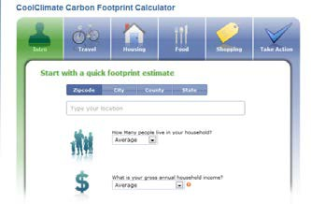

As a student, you may have a very low income. However, you should guesstimate the portion of your family income that you receive. This populates the calculator with more accurate defaults and allows you to see how your energy use compares to that of households of similar size and income in your area. None of this information is saved by the Berkeley website. You may, however, choose not to fill in this section. This will not affect later calculations.

4. Move mouse over the orange question mark for more information.

**Credit:** All screenshot images are used with permission from coolclimate.berkeley.edu

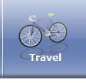**Travel**:

5. Click on the “Travel” tab.

a) Write down how many miles your vehicle is driven in one year.

b) Write down how many miles per gallon your vehicle gets. If you are unsure, go to https://[www.fueleconomy.gov/feg/findacar.shtml.](http://www.fueleconomy.gov/feg/findacar.shtml) Use the column that best describes the kind of driving each vehicle is primarily used for. For example, if you mostly do highway driving, choose the MPG in the HWY column.

c) Back on the carbon footprint calculator, write down any public transportation or flights you have taken in the past year for leisure (not including business travel). You can identify the specific type of public transportation you take by clicking on the advanced tab for more options.

6. See the emoticon on the calculator, which looks like Figure 1.

7. Write down the GHG emissions from your household’s **total travel** in tons of

CO2 /year on the Data Sheet (data chart in question 2).

8. Look at the graph on the bottom of the carbon calculator (Figure 2). You can see which travel subcategory made the greatest contribution to the total carbon emissions for travel. Mouse over each subcategory to view the tons of CO2 /year emitted.

**Figure 1**

**Figure 2**

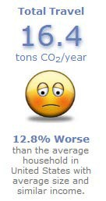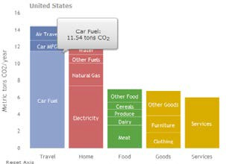

**Housing**:

9. Click on the “Housing” tab. You can set these values at AVERAGE, unless you know this data.

a. Type in your annual electricity, natural gas, heating oil, or other fuel use in this section. Your utility bills will contain the information necessary to fill out this section. For more accurate results, average several months of statements from different seasons to extrapolate energy use for a year.

b. Under “electricity,” you will be asked for the percent purchased from a clean-energy program. Leave this value at zero unless you know that you are enrolled in a utility program that allows customers to pay more for renewable energy.

c. Estimate how much more or less water your household uses compared to similar households. For example, if you have a large lawn or if everyone takes long showers, then move the dial above average. If you consciously use less water, then move the dial somewhat lower than average.

10. Write down the **total housing** emissions in tons of CO2 /year on the Data Sheet (data chart 2).

**Food and Shopping:**

11. In the next two sections, you will calculate the secondary sources of CO2 emissions. Producing and transporting our food, clothes, and other supplies require a great deal of energy and produce high emissions of CO2 and other greenhouse gases.

a) Use your best judgment to fill out this section. For example, if your household eats a lot of meat compared to other households you know, adjust the meat lever up a little from the average.

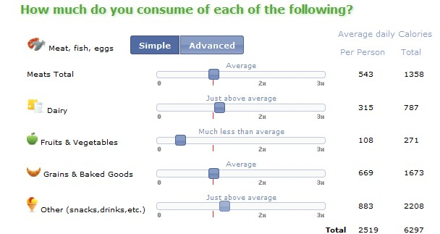

If you would like to be more precise, spend one day writing a food journal for you and your housemates/ family. You can calculate the caloric values for each food item by using https://[www.choosemyplate.gov/SuperTracker/foodtracker.aspx.](http://www.choosemyplate.gov/SuperTracker/foodtracker.aspx) On the carbon footprint calculator, move the lever up or down to record the caloric intake from each of the food groups listed in the calculator.

b) For the shopping section, if you think your house buys a lot less than other college students you know, adjust the lever down a little from the average. You can also use the advanced feature and input dollar amounts. Remember, the site does not save this information.

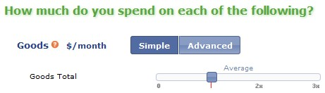

12. Write the **total food** and **total shopping** GHG emissions in tons of CO2 /year on the Data Sheet (chart on question 2).

13. Click on the “Take Action” tab. Before you click on anything else, write the **total footprint** in tons of

CO2 /year on the Data Sheet (data chart in question 2).

Reducing My Carbon Footprint:

1. List TWO ways you can reduce your carbon footprint.

2. Under the “Take Action” tab, look at the list of possible actions. Decide on some actions that you believe you might try to implement in the near future. Place a check mark next to those actions listed on the Data Sheet (question 3).

3. Click on the actions that you might undertake (see Arrow 1). For example, if you decided to ride your bike to school, click on “Ride my bike.” A pull-down menu will appear. Fill in how much of a change you would like to make.

4. Click on the “pledge” button. That will highlight this button green (see Arrow 2).

5. Repeat for all of the selected actions.

6. Write down the **total reductions** in tons of CO2 /year in the Data Sheet (question 4).

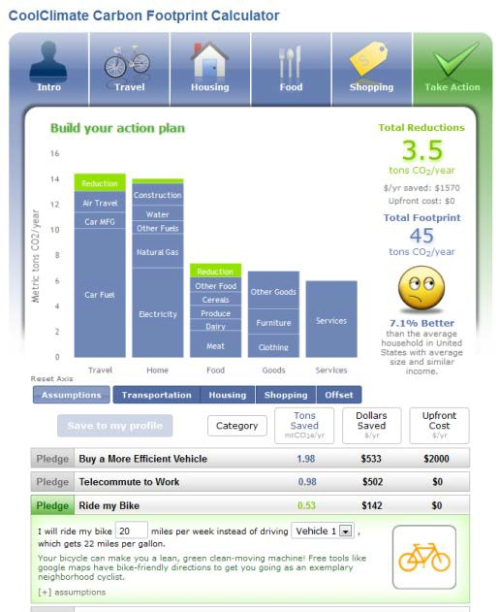

**Arrow 1**

**Arrow 2**

**Data Sheet**

**Instructions:** Answer all four questions below. To answer 2–4, you will need the data from the online carbon footprint calculator.

**What Is My Carbon Footprint?**

1. Record your data below.

2. Data chart:

|  |  |  |  |  |  |
| --- | --- | --- | --- | --- | --- |
|  | Total Travel  (tons of CO 2 /year) | Total Housing  (tons of CO 2 /year) | Total Food  (tons of CO 2 /year) | Total Shopping  (tons of  CO 2 /year) | Total footprint  **before reductions** (tons of CO 2 /year) |
| **Your**  **household’s**  carbon footprint |  |  |  |  |  |

**Reducing My Carbon Footprint:**

3. Check the actions your family would be willing to take to reduce your carbon footprint.

|  |  |  |  |
| --- | --- | --- | --- |
| Buy a more efficient vehicle | Maintain my vehicles | Turn down thermostat in winter | Offset remaining housing |
| Telecommute to work | Carpool to work | Turn up thermostat in summer | Go on a low-carbon diet |
| Ride my bike | Reduce air travel | Choose Energy Star fridge | Go organic |
| Take public transportation | Offset remaining transportation | Purchase green electricity | Offset remaining shopping |
| Practice eco-driving | Switch to CFLs | Line-dry clothing | Other: |

4. What is your **total reduction**, in tons of CO2 /year, if you take the above action(s)?  
 _______________tons of CO2 /year

**Questions:**

|  |  |  |  |  |  |
| --- | --- | --- | --- | --- | --- |
|  | Total Travel  (tons of CO 2 /year) | Total Housing  (tons of CO 2 /year) | Total Food  (tons of CO 2 /year) | Total Shopping  (tons of CO 2 /year) | Total  footprint **before reductions** (tons of  CO 2 /year) |
| **National average**  carbon footprint | 14.6 | 14.1 | 7.0 | 12.8 | 48.5 |

1. The chart above shows the national average carbon footprints for different categories per household.

How do your carbon footprints compare?

2. In which category does your household produce the largest carbon footprint?

3. Which specific action contributes to that large carbon footprint? (for example, if housing was the category that produced the largest carbon footprint, was your electricity use or your natural gas use responsible?)

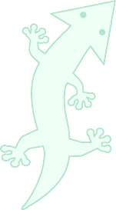

4. In which category does your household produce the smallest carbon footprint?

5. From your list of actions to reduce your carbon footprint, select one and explain why you chose that action. Consider how much of an impact this action will have on your carbon footprint and on your lifestyle.

6. If every household in the US pledged to reduce their carbon footprint by the same amount as you, how many tons of CO2 would we avoid putting into the atmosphere? (According to a 2011 report by the

US Census Bureau, there are about 114,761,359 households in the US.) Show your calculations.

About the Holiday Lectures on Science and BioInteractive.org

As part of its mission to strengthen science education, HHMI presents the Holiday Lectures on Science, an annual series that brings the latest developments in a rapidly moving field of research into the classroom. The lectures are given by HHMI investigators and other leading scientists. The 2012 Holiday Lectures, *Changing Planet: Past, Present, Future*, are the 20th in the series, which began in 1993.

To complement the Holiday Lectures and enhance their usefulness in the classroom, HHMI produces a variety of free science education materials. Lecture summaries, biographies of the lecturers, and other resources are available at [www.holidaylectures.org.](http://www.holidaylectures.org/) DVDs and CD-ROMs can be ordered through HHMI’s Catalog at [http://catalog.hhmi.org.](http://catalog.hhmi.org/)

The BioInteractive website (www.BioInteractive.org) features virtual labs, animations, and other engaging instructional materials. They can be used to supplement the lecture topics or to learn important concepts in the biomedical sciences.

**Department of Science Education**

*About the Howard Hughes Medical Institute*

The Howard Hughes Medical Institute is a nonprofit medical research organization that employs hundreds of leading biomedical scientists working at the forefront of their fields. In addition, through its grants program and other activities, HHMI is helping to enhance science education at all levels and to maintain the vigor of biomedical science worldwide. Headquartered in Chevy Chase, Maryland, HHMI is one of the world's largest philanthropies, with laboratories across the United States and grants programs throughout the world.

The views and opinions expressed in this publication are not necessarily those of the Trustees or management of the

4000 Jones Bridge Road, Chevy Chase, MD 20815 (301) 215-8500 • [biointeractive@hhmi.org](mailto:biointeractive@hhmi.org)

What is My Carbon Footprint? Published January 2013 [www.BioInteractive.org](http://www.BioInteractive.org/)



Howard Hughes Medical Institute.



Different footprint calculators will give you different answers depending on how the results are weighted.   
Generally, you get similar answers from any online calculator of carbon footprint. We will compare.

Having completed the Cool Climate Berkeley footprint calculator, try this one from the Global Footprint Network:  
Got to the website: [www.footprintnetwork.org](http://www.footprintnetwork.org) Open the Footprint Science window.  
 Open Footprint Basics.

Footprint Basics

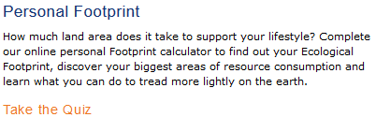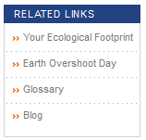Under Related Links, open “Your Ecological Footprint”. Then **Take the Quiz** Note: you are a **NEW USER**. Do not enter email address.

**After completing quiz, answer:**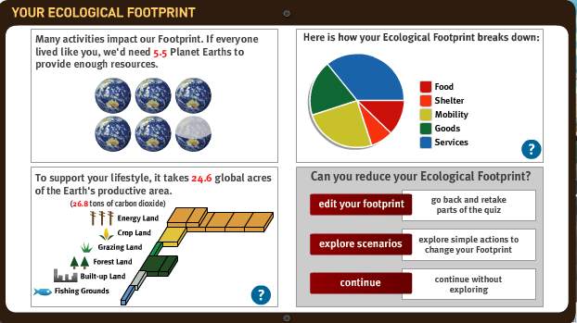If everyone lived like you,   
how many Earths would we need?  
**_________________________**

To support your lifestyle, record:

1. You need how many   
   global acres? _______
2. You use how many tons of   
   carbon dioxide? ___________
3. What are the two largest portions  
   of your Ecological Footprint?  
   **_________________________  
   _________________________**

**Ecological WealtH of nations**

Ecological assets are at the core of every nation's long-term wealth. Yet today, population growth and consumption patterns are putting more pressure on our planet's ecosystems, as seen in water shortages, reduced cropland productivity, deforestation, biodiversity loss, fisheries collapse and climate change.

Ecological Footprint Accounting compares:  
 Ecological Footprint (how much demand human consumption places on the biosphere)  
 to   
 Biocapacity (the area, or supply, of productive land available to meet this demand).

**TO DO**

Compare the ecological footprints of five countries, one from each continent: North America, South America, Europe, Asia, and Africa. To do this, open Footprint for nations, under OUR WORK tab.

Footprint for nations

World Footprint

Find and CLICK TO EXPLORE the interactive world map.

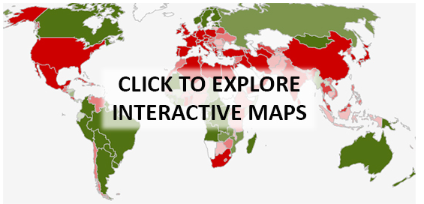

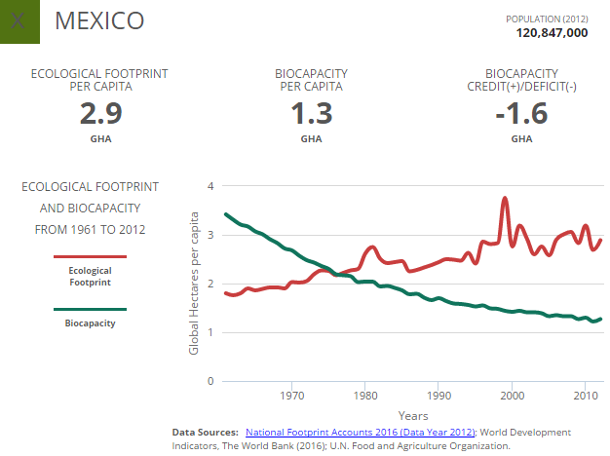

Click on a country to see its :  
  
 **Ecological footprint** *per capita* **Biocapacity** *per capita* **Biocapacity — Ecological footprint**  
 (Negative values show   
 countries that exceed their  
 available resources.)

Click on five countries. From each graph, for the years 2000 and 2010, read and record the   
**Ecological Footprint per capita** and **Biocapacity per capita**.   
Use the 2000 and 2010 data to predict values for 2030. (Assume the change from 2000 to 2010, a ten year period, is predictive of the twenty year period from 2010 to 2030.)

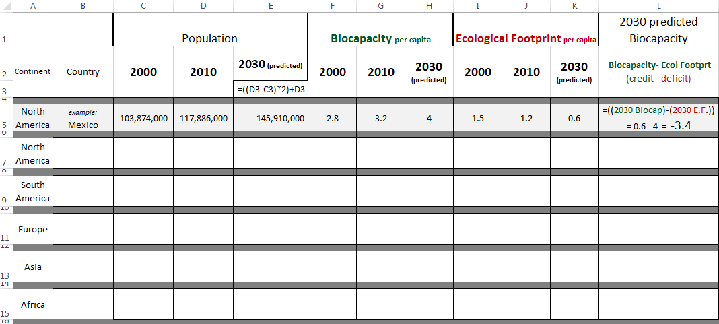

How do your values for Predicted 2030 Biocapacity appear?

How many countries have NEGATIVE predicted 2030 Biocapacity values? ____________

How old will you be in 2030? __________ Will you have children? ________ How many? _________  
  
  
  
Let’s assume that you have a child by 2030.

Assuming your child attends college at the same age as you, what year would they be attending URI? _____

What will these values look like when your children are in BIO 104 at URI? In 2040? In 2050?

_______________________________________________________________________________________

_______________________________________________________________________________________

Complete the following chart and show to your TA before leaving the lab.

